**Hong Kong Institute of Vocational Education (Chai Wan)**

**Department of Information Technology**

**Higher Diploma in Software Engineering (IT114105)**

**Final Year Project (ITP4913M)**

**Final Report**

**(2020/2021)**

Local Market

|  |  |
| --- | --- |
| Supervisor: | Mr. Lo Wing Wah Terence |
| Co-supervisor: | Mr. Chim Pang Hung |
| Student: | Fung Ka Wai  Wong King Hong  Cen WeiCheng  Cheng Chun Hei |

We declare that this is a group project and that no part of this submission has been copied from any other student’s work or from any other source except where due acknowledgement is made explicitly in the text, nor has any part been written for us by another person.

|  |  |  |
| --- | --- | --- |
| **Student** | **Contribution to the project (%)**  **(Total 100%)** | **Signature** |
| Fung Ka Wai |  |  |
| Wong King Hong |  |  |
| Cen WeiCheng |  |  |
| Cheng Chun Hei |  |  |

1 Abstract

The project was developed based on the concept of a smart district and is designed to improve daily work efficiency. The project focuses on the development of market and centralized data processing systems. The following report will describe the design concept of our system including problems which we discovered and the proposed solution for the problems as well as the requirements of the system. It also includes Project Plan and Tentative Design.

**Table of Content**

1 Abstract 2

2 Introduction 6

2.1 Background of the project 6

2.2 Aim of the project 7

3 Solution of the problems 8

4 Requirement analysis 11

4.1 Actor Description 11

4.2 Functional Requirement 12

4.3 General Function 13

4.4 Non-Functional Requirement 15

5 Use case diagram 16

5.1 Normal User Use Case 16

5.2 Shopkeeper User Case 17

5.3 System Admin Use case 18

6 Initial use case descriptions 19

7 Base use case descriptions 23

8 Data Dictionary 42

9 Detailed database design 44

9.1 ER-Diagram 44

9.2 Data Description 45

**9.2.1 Client** 45

**9.2.2 Shopkeeper** 46

**9.2.3 Stall** 46

**9.2.4 Goods** 47

**9.2.5 Coupon** 47

**9.2.6 Promotion** 48

**9.2.7 ShoppingCart_Items** 48

**9.2.8 Record** 49

**9.2.9 Record_Items** 49

**9.2.10 Recipe** 50

**9.2.11 Recipe_Items** 50

10 Architecture of the proposed system 51

10.1 Software architecture 51

10.2 Network architecture 53

10.3 Intranet architecture 53

10.4 Hardware and software specification 54

11 Requirement specification 55

11.1 Class Diagram 55

11.2 3-tier Sequence Diagrams 56

**11.2.1 Register successful** 56

**11.2.2 Register unsuccessful** 57

**11.2.3 Login successful** 57

**11.2.4 Login unsuccessful** 58

**11.2.5 Add goods to shopping cart (Customer)** 58

**11.2.6 Setting Coupon (Stall)** 59

**11.2.7 Order (payment with QR code)(Web) (Customer)** 59

[**11.2.8 Order (payment with QR code)(Mobile App) (Customer)** 60

**11.2.9 Order (payment with Credit card) (Customer)** 60

**11.2.10 Order record (Customer)** 61

**11.2.11 Order List (Stall)** 61

**11.2.12 Promotion Request (Stall)** 62

**11.2.13 Accept Promotion (Administrator)** 62

**11.2.14 Edit Personal Information (All Permission)** 63

11.3 State Machine Diagrams 64

11.3.1 Login Controller (Login) 64

11.3.2 Order Controller (Processing order) 65

11.3.3 External Payment Gateway (Payment) 66

12 Critical evaluation 67

12.1 Problems/Difficulties Encountered 67

12.2 Delays/Changes in project Schedule 67

12.3 Limitation of the proposed system 68

12.4 Suggested progression Route 68

13 Detail project plan 69

13.1 Methodology 69

13.2 Schedule 70

13.3 Deliverables 71

13.4 Software tools 72

13.5 Facilities and Hardware needed 72

13.6 Server Hardware Recommendation 72

14 User Interface Design 73

14.1 Website 73

14.1.1 Home Page 73

14.1.2 Shop List 75

14.1.3 Login 76

14.1.4 Register 77

14.1.5 Upload Product 78

14.1.6 Promotion Request 79

14.1.7 Stall List 80

14.1.8 Promotion Request Control 81

14.1.9 Promotion Accept Page 82

14.2 Mobile app 83

14.2.1 Menu Bar 83

14.2.2 Login 84

14.2.3 Sign Up 85

14.2.4 Update Personal information 86

14.2.5 History Record 87

14.2.6 Logout 88

14.2.7 Home 89

14.2.8 Local fresh 90

14.2.9 Shopping Cart 91

14.2.10 Make orders (1) 92

14.2.11 Offline QR Code Scan 93

14.2.12 Make order (2) 94

15 Test Case 95

15.1 Test Case(Web) 95

15.2 Test Case(Mobile application) 107

16 User guide 114

16.1 Website (public user) 114

16.1.1 Search Ingredient 114

16.1.2 Login 115

16.1.3 Register a normal user account 116

16.2 Control Panel (Shopkeeper & Admin) 117

16.2.1 Upload product(Shopkeeper) 117

16.2.2 Upload product(Shopkeeper) 118

16.2.3 Add new stall(Admin) 119

16.2.4 Accept promotion request 120

16.3 Mobile System (Customer) 121

16.3.1 Sign up 121

16.3.2 Login 123

16.3.4 Search for Ingredients 125

16.3.6 Edit personal Information 127

16.3.7 Recipe 128

16.3.8 Local Fresh 129

16.3.9 Shopping Cart 130

16.3.10 Make an order 131

16.3.11 History Record 135

17 References 137

2 Introduction

2.1 Background of the project

As a resident, we all hope to benefit from the Smart District Project to make our life more convenient and more cost-effective. Therefore, we start with the aspect of food which is one of the basic necessities and think of the problems that residents may meet in the process of buying food.

We are now under the epidemic, so we will eat outside as little as possible. Instead, more people will go out to buy food and cook at home. In the market, the general public is more inclined to use contactless payment methods for consumption, and merchants also operate by using online payment methods to enhance market competitiveness and attract customers. Therefore, we want to provide the market with some suitable solutions (such as online payment and delivery functions) to develop in the new business environment after the epidemic.

The most residents may have the experience of spending a lot of time buying food and not being able to buy the food they want to buy. In our opinion, we need to use the Internet to create a platform that allows residents to receive recommendations of products and stores. So that they can buy the most expected product at a relatively low price and benefit from online payment and delivery. It will save much time and money, which fits our idea of creating a smart district.

2.2 Aim of the project

The aim of this project is to solve the following problems:

1. People often cannot avoid going to market and touching with cash, which is unsanitary and increases the risk of infection.

2. For some people who are not often buying food, it is hard to find the ingredient they want to buy. In addition, they may not know the opening hours of the store and will find that the store is already closed when they go to the store. People won’t have this problem in online market.

3. People living in Hong Kong are very busy that they might not have time to buy goods in the market or local stall. They often get off work after the market close, so this platform can help them to buy goods at any time.

3 Solution of the problems

|  |
| --- |
| **Problem 1**  Difficult to compare the price  **Description of the problem environment:**  It is difficult for people to compare the price of an ingredient in different store. People may spend an hour to compare the price in different store and buy it. That is a time wasting and physical strength consuming activity. |
| **Solution:**  A complete database to collect ingredients prices from different shops. Provide comparison results of ingredients prices.  **Advantage:**  It can solve the problem of price transparency, so that users can buy cheaper ingredients with corresponding quality in less time, without spending a lot of time and energy to compare prices in different stores. |

|  |
| --- |
| **Problem 2**  Some small-scale shop with low visibility may need help  **Description of the problem environment:**  Some small-scale shop is low visible and less people are buying their product. Without these shops, the chain store can easily monopolize the market and sell product to customer in a much higher price. |
| **Solution:**  Shops can increase their visibility by uploading their product prices and publishing promotion information. Our app will disclose the information of this type of store to attract more people to shop.  **Advantage:**  Our app will disclose the product prices and their promotion of this type of store to attract more people to shop to help the store increase its visibility. |

|  |
| --- |
| **Problem 3:**  Some people are hard to find the ingredient  **Description of the problem environment:**  For some people who are not often buying food, it is hard to find the ingredient they want to buy. In addition, they may not know the opening hours of the store and will find that the store is already closed when they go to the store. |
| **Solution:**  Price searching function and food stall price analysis can help users to find the most suitable store quickly.  **Advantage:**  Our app can help some new residents who Just moved in the district find the stalls which fit their requirements in a short time. |

4 Requirement analysis

4.1 Actor Description

|  |  |
| --- | --- |
| **Actor Name** | **Description** |
| Public user | A user uses the system without login into an account. They can browse goods details, register a new customer account and login to existing account. |
| Client | Client has a customer account which contains their email address, username and phone number. They browse goods, recipes and shop. Moreover, they can manage account info, add goods to cart and order goods. |
| Shopkeeper | A user who owns a shop in local market. They can sell their product in this platform. They can also manage their shop info. |
| Staff | The staff handle the product delivery process. When they collected all the product of an order, they can start the delivery to the customer. |
| External payment gateway | External payment gateway processes online payment while an order is created. |
| System admin | System admin is the one to manage the system. They have permissions to manage user account like create new shopkeeper and staff account, edit user info, delete account. They can also delete goods and order. |

## 4.2 Functional Requirement

**Normal User:**

1. Write post on community to share food purchasing tips, experience and recipe.
2. Leave a comment in other user’s post
3. Generate a shopping checklist by choosing the food materials or generate it from recipe share by the other.
4. Edit their account information. Including password, user nick name, and update new phone number.

**Shopkeeper:**

1.Post a sale event with details like event title, event date and content of the event.

2.Edit the details of the store. Including opening hours and location etc.

**Admin:**

1.Delete or mute any type of account.

2.Delete or modify any type of post including price share record and community post.

3.Upgrade a normal account to a shopkeeper account.

## 4.3 General Function

**Register:**

1. People can register a normal account by entering the username, password, e-mail and phone number.

2. They need to enter the confirm number received by their mobile phone to confirm their identity.

**Login:**

1. People can access different user group permission such as normal user, shopkeeper and admin.

2. When the password does not match with the account, system will tell the user to input again.

3. After inputting the wrong password for five times, the account will be locked. A message will send to phone number bind with the account to confirm identity of the user logging in.

**View different data:**

1. View price reference, community posts, sales event and store details.

**Search function:**

1. Enter the food name in the search bar and the system will provide user the food with similar name to choose.

2. The searching result include the price of the food, the post with the tag on it.

## 4.4 Non-Functional Requirement

**User Interface**

* The content planning should have high readability, resolution and conciseness to provide a better user experience.
* The User Interface can be display in different language including English, Simplified Chinese and Traditional Chinese.
* Font size and style can be change cater to needs.

**Fault tolerance**

* The system will remind and prevent the user when input error happens. For example, user input invalid symbol in password.

**Security**

* Sales record, user information will be encrypted to make sure no employee or hacker can steal the personal information.
* The server should content a firewall to block every packet with virus in it.

**Backup**

* Incremental backup will back up the sales record, showcase record and item quantity every day to make sure system can work normally after server failure.
* Full back up once a year, every full backup will save for three years.

5 Use case diagram

5.1 Normal User Use Case

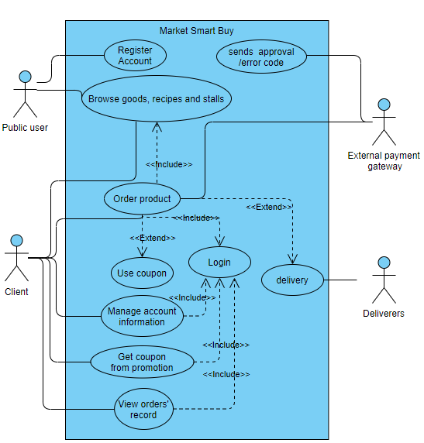

5.2 Shopkeeper User Case

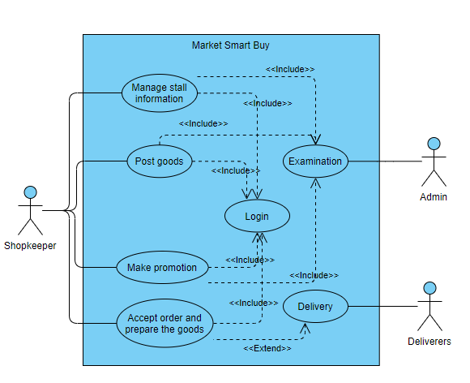

5.3 System Admin Use case

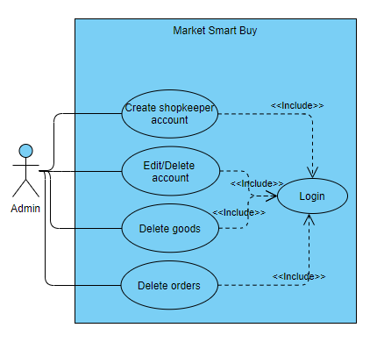

6 Initial use case descriptions

|  |  |
| --- | --- |
| Use case: | Register Customer account |
| Use case ID: | UC-PU-01 |
| Actor(s): | Public user |
| Description: | Public user enters the user name, password, email and phone number to register a new customer account. |

|  |  |
| --- | --- |
| Use case: | Login account |
| Use case ID: | UC-PU-02 |
| Actor(s): | Public user |
| Description: | In the login page, public user enters the username and password to login their existing account. |

|  |  |
| --- | --- |
| Use case: | Change password |
| Use case ID: | UC-U-01 |
| Actor(s): | Client, Shopkeeper |
| Description: | Change account’s password after entering current password. |

|  |  |
| --- | --- |
| Use case: | Order product |
| Use case ID: | UC-C-01 |
| Actor(s): | Client |
| Description: | Client can select one of the products and add the product to cart. After the user added the goods they want into the cart. They can place order of the product in cart. |

|  |  |
| --- | --- |
| Use case: | Manage account information |
| Use case ID: | UC-C-02 |
| Actor(s): | Client |
| Description: | Client can edit account information (Name, Phone number and Email address). |

|  |  |
| --- | --- |
| Use case: | View order details |
| Use case ID: | UC-C-03 |
| Actor(s): | Client |
| Description: | Client can view the details of order record (Product, Status, price and so on). |

|  |  |
| --- | --- |
| Use case: | Get coupon from promotional event |
| Use case ID: | UC-C-04 |
| Actor(s): | Client |
| Description: | Client can get coupon from promotional event hold by shopkeeper. |

|  |  |
| --- | --- |
| Use case: | Use coupon |
| Use case ID: | UC-C-05 |
| Actor(s): | Client |
| Description: | Client can use coupon while client is making an order and the coupon is available. |

|  |  |
| --- | --- |
| Use case: | Sell goods |
| Use case ID: | UC-SK-01 |
| Actor(s): | Shopkeeper |
| Description: | Shopkeeper can post goods for sale. |

|  |  |
| --- | --- |
| Use case: | Manage shop info |
| Use case ID: | UC-SK-02 |
| Actor(s): | Shopkeeper |
| Description: | Shopkeepers can edit their stall information. |

|  |  |
| --- | --- |
| Use case: | Hold promotional event |
| Use case ID: | UC-SK-03 |
| Actor(s): | Shopkeeper |
| Description: | Shopkeepers can hold promotional event like providing coupon for clients. |

|  |  |
| --- | --- |
| Use case: | Accept order |
| Use case ID: | UC-SK-04 |
| Actor(s): | Shopkeeper |
| Description: | Shopkeepers can accept orders when client order products. |

|  |  |
| --- | --- |
| Use case: | Delivery |
| Use case ID: | UC-S-01 |
| Actor(s): | Staff |
| Description: | Staff can verify the goods of the order is arrived and notice client it will deliver to them soon. |

|  |  |
| --- | --- |
| Use case: | Create shopkeeper account |
| Use case ID: | UC-A-01 |
| Actor(s): | System admin |
| Description: | Admin can create shopkeeper account by entering the username and password of the account. Admin also have to create a shop for shopkeeper and input the name, opening hour, location and status of the shop. |

|  |  |
| --- | --- |
| Use case: | Create staff account |
| Use case ID: | UC-A-02 |
| Actor(s): | System admin |
| Description: | Admin can create staff account by entering the username and password of the account. |

|  |  |
| --- | --- |
| Use case: | Edit account information |
| Use case ID: | UC-A-03 |
| Actor(s): | System admin |
| Description: | Admin can edit any type of account (except admin) in the account manage page. |

|  |  |
| --- | --- |
| Use case: | Delete account infomation |
| Use case ID: | UC-A-04 |
| Actor(s): | System admin |
| Description: | Admin can delete any type of account (except admin) in the account manage page. |

|  |  |
| --- | --- |
| Use case: | Delete goods |
| Use case ID: | UC-A-05 |
| Actor(s): | System admin |
| Description: | Admin can delete a specify good, so it no longer show in the online market. |

|  |  |
| --- | --- |
| Use case: | Delete order |
| Use case ID: | UC-A-06 |
| Actor(s): | System admin |
| Description: | Admin can delete an order placed by customer. |

7 Base use case descriptions

|  |  |
| --- | --- |
| Use case name | Register Customer account |
| Use case ID | UC-PU-01 |
| Super use case | / |
| Actor(s) | Public user |
| Brief description | Public user enters the user name, password, email and phone number to register a new customer account. |
| Pre-Conditions | / |
| Post-Conditions | A new customer account created. |
| Flow of events | 1. enter username, password, email and phone number.  2. click Create  3. verify phone number and email |
| Alternative flows and exceptions | Username, email or phone number has been used to register an account. |
| Priority | high |
| Non-behavioral requirements | / |
| Assumptions | / |
| Issues | / |
| Source | / |

|  |  |
| --- | --- |
| Use case name | Login account |
| Use case ID | UC-PU-02 |
| Super use case | / |
| Actor(s) | Public user |
| Brief description | In the login page, public user enters the username and password to login their existing account. |
| Pre-Conditions | User has an account. |
| Post-Conditions | Login to an account. |
| Flow of events | 1. enter username, password.  2. click Login |
| Alternative flows and exceptions | / |
| Priority | high |
| Non-behavioral requirements | The password should be hidden in “*” to prevent other people knowing the password. |
| Assumptions | / |
| Issues | / |
| Source | / |

|  |  |
| --- | --- |
| Use case name | Change password |
| Use case ID | UC-U-01 |
| Super use case | / |
| Actor(s) | Client, shopkeeper |
| Brief description | Change account’s password after entering current password. |
| Pre-Conditions | User has an account. |
| Post-Conditions | Password of the account change. |
| Flow of events | 1. enter current password  2. enter new password |
| Alternative flows and exceptions | / |
| Priority | high |
| Non-behavioral requirements | The password should be hidden in “*” to prevent other people knowing the password. |
| Assumptions | / |
| Issues | / |
| Source | / |

|  |  |
| --- | --- |
| Use case name | Order product |
| Use case ID | UC-C-01 |
| Super use case | / |
| Actor(s) | Client |
| Brief description | Client can select one of the products and add the product to cart. After the user added the goods they want into the cart. They can place order of the product in cart. |
| Pre-Conditions | User login to a client account. |
| Post-Conditions | A new order has been placed. |
| Flow of events | 1. select some goods and add it to cart  2. check the shopping cart  3. click order |
| Alternative flows and exceptions | Can’t order when nothing added to the shopping cart |
| Priority | high |
| Non-behavioral requirements | / |
| Assumptions | / |
| Issues | / |
| Source | / |

|  |  |
| --- | --- |
| Use case name | Manage account information |
| Use case ID | UC-C-02 |
| Super use case | / |
| Actor(s) | Client |
| Brief description | Client can edit account information (Name, Phone number and Email address). |
| Pre-Conditions | User login to a client account. |
| Post-Conditions | Account information will be changed. |
| Flow of events | 1. check account profile  2. edit account information (username, phone number and email address)  3. click modify |
| Alternative flows and exceptions | Account information can’t be change when they are invalid |
| Priority | high |
| Non-behavioral requirements | / |
| Assumptions | / |
| Issues | / |
| Source | / |

|  |  |
| --- | --- |
| Use case name | View order details |
| Use case ID | UC-C-03 |
| Super use case | / |
| Actor(s) | Client |
| Brief description | Client can view the details of order record (Product, Status, price and so on). |
| Pre-Conditions | User login to a client account. |
| Post-Conditions | / |
| Flow of events | 1. go to order history page  2. select one of the order records |
| Alternative flows and exceptions | / |
| Priority | medium |
| Non-behavioral requirements | / |
| Assumptions | / |
| Issues | / |
| Source | / |

|  |  |
| --- | --- |
| Use case name | Get coupon from promotion |
| Use case ID | UC-C-04 |
| Super use case | / |
| Actor(s) | Client |
| Brief description | Client can get coupon from promotional event hold by shopkeeper. |
| Pre-Conditions | User login to a client account. |
| Post-Conditions | / |
| Flow of events | 1. click on a promotion posted by shopkeeper.  2. click claim |
| Alternative flows and exceptions | / |
| Priority | medium |
| Non-behavioral requirements | / |
| Assumptions | / |
| Issues | / |
| Source | / |

|  |  |
| --- | --- |
| Use case name | Use coupon |
| Use case ID | UC-C-05 |
| Super use case | / |
| Actor(s) | Client |
| Brief description | Client can use coupon while client is making an order and the coupon is available. |
| Pre-Conditions | User login to a client account. |
| Post-Conditions | / |
| Flow of events | go to shopping cart page  select available coupon and use it.  confirm order |
| Alternative flows and exceptions | / |
| Priority | medium |
| Non-behavioral requirements | / |
| Assumptions | / |
| Issues | / |
| Source | / |

|  |  |
| --- | --- |
| Use case name | Sell goods |
| Use case ID | UC-SK-01 |
| Super use case | / |
| Actor(s) | Shopkeeper |
| Brief description | Shopkeeper can post goods for sale. |
| Pre-Conditions | User login to a shopkeeper account. |
| Post-Conditions | A new good appear in the online market. |
| Flow of events | 1. choose the type and enter the name, price of the good  2. click sell |
| Alternative flows and exceptions | / |
| Priority | medium |
| Non-behavioral requirements | / |
| Assumptions | / |
| Issues | / |
| Source | / |

|  |  |
| --- | --- |
| Use case name | Manage shop info |
| Use case ID | UC-SK-02 |
| Super use case | / |
| Actor(s) | Shopkeeper |
| Brief description | Shopkeepers can edit their stall information. |
| Pre-Conditions | User login to a shopkeeper account. |
| Post-Conditions | / |
| Flow of events | 1. Go to Shop Management page  2. edit information of the stall (Name, opening hour, location and status)  3. click modify |
| Alternative flows and exceptions | / |
| Priority | medium |
| Non-behavioral requirements | / |
| Assumptions | / |
| Issues | / |
| Source | / |

|  |  |
| --- | --- |
| Use case name | Hold promotional event |
| Use case ID | UC-SK-03 |
| Super use case | / |
| Actor(s) | Shopkeeper |
| Brief description | Shopkeepers can hold promotional event like providing coupon for clients. |
| Pre-Conditions | User login to a shopkeeper account. |
| Post-Conditions | A new event appears. |
| Flow of events | 1. Go to hold promotion page  2. enter event title, content  3. If needed, add coupon and set the quantity of it.  4. click Finish |
| Alternative flows and exceptions | / |
| Priority | medium |
| Non-behavioral requirements | / |
| Assumptions | / |
| Issues | How to handle different type of coupon? |
| Source | / |

|  |  |
| --- | --- |
| Use case name | Accept order |
| Use case ID | UC-SK-04 |
| Super use case | / |
| Actor(s) | Shopkeeper |
| Brief description | Shopkeepers can accept orders when client order products. |
| Pre-Conditions | User login to a shopkeeper account. |
| Post-Conditions | The status of the goods in the order will change to preparing. |
| Flow of events | 1. go to order list  2. click “accept” of the order |
| Alternative flows and exceptions | / |
| Priority | medium |
| Non-behavioral requirements | / |
| Assumptions | / |
| Issues | / |
| Source | / |

|  |  |
| --- | --- |
| Use case name | Delivery |
| Use case ID | UC-S-01 |
| Super use case | / |
| Actor(s) | Staff |
| Brief description | Staff can verify the goods of the order is arrived and notice client it will deliver to them soon. |
| Pre-Conditions | User login to a staff account. |
| Post-Conditions | A notification will send to client’s email and phone that the order is delivering. |
| Flow of events | 1. Go to order list  2. click verify near the order |
| Alternative flows and exceptions | / |
| Priority | medium |
| Non-behavioral requirements | / |
| Assumptions | / |
| Issues | / |
| Source | / |

|  |  |
| --- | --- |
| Use case name | Create shopkeeper account |
| Use case ID | UC-A-01 |
| Super use case | / |
| Actor(s) | System admin |
| Brief description | Admin can create shopkeeper account by entering the username and password of the account. Admin also have to create a shop for shopkeeper and input the name, opening hour, location and status of the shop. |
| Pre-Conditions | User login to an admin account. |
| Post-Conditions | A new shopkeeper account created. |
| Flow of events | 1. enter username and password of shopkeeper account.  2. enter stall name, opening hour, location and status of the shop.  3. click create |
| Alternative flows and exceptions | / |
| Priority | medium |
| Non-behavioral requirements | / |
| Assumptions | / |
| Issues | / |
| Source | / |

|  |  |
| --- | --- |
| Use case name | Create staff account |
| Use case ID | UC-A-02 |
| Super use case | / |
| Actor(s) | System admin |
| Brief description | Admin can create staff account by entering the username and password of the account. |
| Pre-Conditions | User login to an admin account. |
| Post-Conditions | A new staff account created. |
| Flow of events | 1. enter username and password of staff account.  2. click create |
| Alternative flows and exceptions | / |
| Priority | medium |
| Non-behavioural requirements | / |
| Assumptions | / |
| Issues | / |
| Source | / |

|  |  |
| --- | --- |
| Use case name | Edit account information |
| Use case ID | UC-A-03 |
| Super use case | / |
| Actor(s) | System admin |
| Brief description | Admin can edit any type of account (except admin) in the account manage page. |
| Pre-Conditions | User login to an admin account. |
| Post-Conditions | A new staff account created. |
| Flow of events | 1. Go to Account Manage page  2. select one of the accounts  3. edit account information  4. click modify |
| Alternative flows and exceptions | / |
| Priority | medium |
| Non-behavioural requirements | / |
| Assumptions | / |
| Issues | / |
| Source | / |

|  |  |
| --- | --- |
| Use case name | Delete account |
| Use case ID | UC-A-04 |
| Super use case | / |
| Actor(s) | System admin |
| Brief description | Admin can delete any type of account (except admin) in the account manage page. |
| Pre-Conditions | User login to an admin account. |
| Post-Conditions | The account and related data will be deleted. |
| Flow of events | 1. Go to Account Manage page  2. select one of the accounts  3. delete account |
| Alternative flows and exceptions | / |
| Priority | medium |
| Non-behavioural requirements | / |
| Assumptions | / |
| Issues | / |
| Source | / |

|  |  |
| --- | --- |
| Use case name | Delete good |
| Use case ID | UC-A-05 |
| Super use case | / |
| Actor(s) | System admin |
| Brief description | Admin can delete a specify good so it no longer show in the online market. |
| Pre-Conditions | User login to an admin account. |
| Post-Conditions | The good will be deleted |
| Flow of events | 1. Go to Goods Manage page  2. click delete near the good |
| Alternative flows and exceptions | / |
| Priority | medium |
| Non-behavioural requirements | / |
| Assumptions | / |
| Issues | / |
| Source | / |

|  |  |
| --- | --- |
| Use case name | Delete order |
| Use case ID | UC-A-06 |
| Super use case | / |
| Actor(s) | System admin |
| Brief description | Admin can delete an order placed by customer. |
| Pre-Conditions | User login to an admin account. |
| Post-Conditions | An order will be deleted |
| Flow of events | 1. Go to Order Manage page  2. click delete near the order |
| Alternative flows and exceptions | / |
| Priority | medium |
| Non-behavioural requirements | / |
| Assumptions | / |
| Issues | / |
| Source | / |

8 Data Dictionary

|  |  |
| --- | --- |
| **Noun** | **Description** |
| User | There are three types of users, normal user, shopkeeper and staff. Normal user can browse goods, recipes and shop. Moreover, they can manage account info, add goods to cart and order goods. Shopkeeper is a user who owns a shop in local market, and they can sell their product and make promotion in this platform. The staff is the admin who manage the system. They have permissions to manage user account like create new shopkeeper and staff account, edit user info, delete account. They can also delete goods and order. |
| Stall | The Shopkeepers may upload their stall information to create an online shop in the platform. |
| Goods | The goods’ information will be inputted by shopkeeper and the system will help them for selling the goods. |
| Record | The order record and transaction record will be saved while a user make an order succeed. |
| Record_Items | The item in one record will be saved separately. |
| ShoppingCart_Items | While users are browsing goods in the system, they can add goods in their own shopping cart. The information of items will be saved in the system automatically. Users can amend and delete items by themselves. |
| Coupon | User can get coupon from some promotion events. The information of coupon will be saved in the system. (applicable store, validity period, discount) |
| Promotion | Promotions are made by shopper. These will provide some discount by coupon for sale. It contains title, content and validity period. |
| Recipe | Recipe is set by admin. User can browse it and add the ingredients of a recipe to his/her shopping cart for making a shopping list. |
| Recipe_Items | While a recipe is made, the information of items will be saved in the system automatically. |

9 Detailed database design

9.1 ER-Diagram

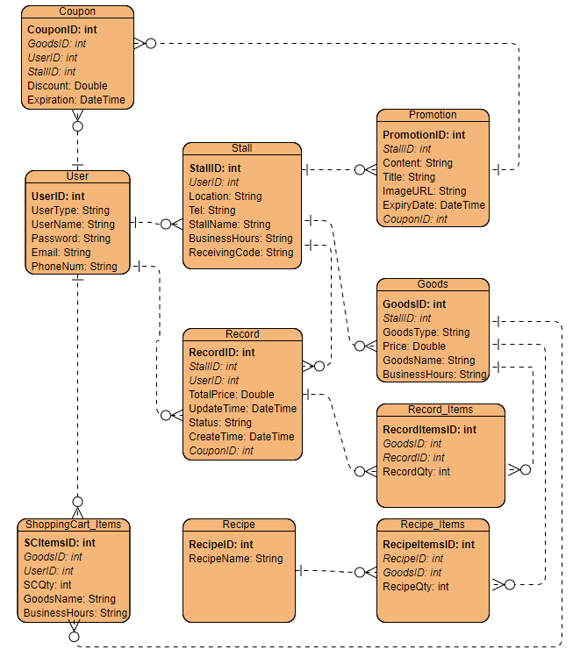

9.2 Data Description

**9.2.1 Client**

|  |  |  |  |  |
| --- | --- | --- | --- | --- |
| **Name** | **Type** | **Length** | **Description** | **Null** |
| cID(PK) | Int | 10 | Client’s id will automatically generate by the system. Unique for any account. | Not Null |
| UserName | String | 30 | UserName defined by user which is used to login to their account | Not Null |
| Passoword | String | 30 | Password set by user which is used to login to their account. It can be changed by user at any time. | Not Null |
| Email | String | 30 | Email is used to receive the latest news and help to reset password. | Null |
| PhoneNum | String | 20 | Phone number is used to order goods in app. | Null |

**9.2.2 Shopkeeper**

|  |  |  |  |  |
| --- | --- | --- | --- | --- |
| **Name** | **Type** | **Length** | **Description** | **Null** |
| skID(PK) | Int | 10 | User’s id will automatically generate by the system. Unique for any account. | Not Null |
| UserName | String | 30 | UserName is used to login to their account | Not Null |
| Passoword | String | 30 | Password is used to login to their account. It can be changed by user at any time. | Not Null |
| sID | Int | 10 | The id of the stall shopkeeper response. | Null |

**9.2.3 Stall**

|  |  |  |  |  |
| --- | --- | --- | --- | --- |
| **Name** | **Type** | **Length** | **Description** | **Null** |
| sID(PK) | Int | 10 | Stall's ID will automatically generate when the stall created. | Not Null |
| skID(FK) | Int | 10 | The owner id of the stall. | Not Null |
| StallName | String | 20 | Name of the stall. | Not Null |
| Location | String | 255 | The address of the stall. | Not Null |
| Tel | String | 20 | The telephone number of the stall. | Not Null |
| BusinessHours | String | 20 | The business hours of the stall.(e.g. “9:00-19:00”) | Not  Null |
| ReceivingCode | String | 200 | The URL of receiving code image for online payment. | Null |

**9.2.4 Goods**

|  |  |  |  |  |
| --- | --- | --- | --- | --- |
| **Name** | **Type** | **Length** | **Description** | **Null** |
| GoodsID(PK) | Int | 10 | Good’s id will automatically generate when a good is uploaded by user. | Not Null |
| GoodsType | String | 5 | Dry Goods(D), Meat(M), Fruits and vegetables(F) | Not Null |
| GoodsName | String | 30 | Good’s name | Not Null |
| Price | Double | 5 | Good’s price | Not Null |
| StallID(FK) | Int | 10 | The StallID of the stall whom the good is belong to. | Not  Null |

9.2.5 Coupon

|  |  |  |  |  |
| --- | --- | --- | --- | --- |
| **Name** | **Type** | **Length** | **Description** | **Null** |
| CouponID(PK) | Int | 10 | Coupon’s id. | Not Null |
| GoodsID(FK) | Int | 10 | The id of goods with available coupon. | Null |
| UserID(FK) | Int | 10 | The owner id of the Coupon. | Not Null |
| StallID(FK) | Int | 10 | The StallID of the stall where the coupon is available. | Null |
| Discount | Double | 10 | The discount of the coupon.(e.g. ‘-5’, ‘0.7’) | Not Null |
| Expiration | DateTime | - | The Expiration time of the coupon. | Not Null |

**9.2.6 Promotion**

|  |  |  |  |  |
| --- | --- | --- | --- | --- |
| **Name** | **Type** | **Length** | **Description** | **Null** |
| PromotionID(PK) | int | 10 | Promotion’s ID | Not Null |
| StallID(FK) | Int | 10 | The StallID of the stall where the coupon is available. | Null |
| CouponID(FK) | Int | 10 | The id of Coupon which promotion may provide. | Not Null |
| Title | String | 20 | The title of the Promotion. | Not Null |
| Content | String | 255 | The content of the Promotion. | Not Null |
| ImageURL | String | 255 | The ImageURL of the cover image. | Not Null |
| ExpiryDate | DateTime | - | The Expiration time of the Promotion. | Not Null |

**9.2.7 ShoppingCart_Items**

|  |  |  |  |  |
| --- | --- | --- | --- | --- |
| **Name** | **Type** | **Length** | **Description** | **Null** |
| SCItemsID(PK) | Int | 10 | ShoppingCart_ItemsID will automatically generate when a good is added to shopping cart by user. | Not Null |
| GoodsID(FK) | Int | 10 | The id of goods which is added. | Null |
| UserID(FK) | Int | 10 | The owner id of the shopping cart. | Not Null |
| StallID(FK) | Int | 10 | The StallID of the stall where the coupon is available. | Null |
| SCQty | Int | 10 | The quantity of the shopping cart’s items. | Not Null |

9.2.8 Record

|  |  |  |  |  |
| --- | --- | --- | --- | --- |
| **Name** | **Type** | **Length** | **Description** | **Null** |
| RecordID(PK) | Int | 10 | RecordID will automatically generate when an order is created. | Not Null |
| GoodsID(FK) | Int | 10 | The id of goods which is added. | Null |
| UserID(FK) | Int | 10 | The id of the user who creates the record. | Not Null |
| TotalPrice | Double | 10 | The TotalPrice of the record. | Null |
| CreateTime | DateTime | - | The time when the record is created. | Not Null |
| UpdateTime | DateTime | - | The time when the status is updated. | Not Null |
| Status | String | 5 | The status of the record. Accept(A), Completed(C), Delivering(D), Reject(R), Waiting for takeaway (W) | Not Null |

**9.2.9 Record_Items**

|  |  |  |  |  |
| --- | --- | --- | --- | --- |
| **Name** | **Type** | **Length** | **Description** | **Null** |
| RecordItemsID  (PK) | Int | 10 | RecordItemsID will automatically generate when the record is created. | Not Null |
| GoodsID(FK) | Int | 10 | The id of goods in the Record. | Null |
| RecordID(FK) | Int | 10 | RecordID which the items are belong to. | Not Null |
| RecordQty | Int | 10 | The quantity of the Record’s items. | Not Null |

**9.2.10 Recipe**

|  |  |  |  |  |
| --- | --- | --- | --- | --- |
| **Name** | **Type** | **Length** | **Description** | **Null** |
| RecipeID(PK) | Int | 10 | RecipeID will automatically generate when a Recipe is created. | Not Null |
| RecipeName | String | 10 | Name of the Recipe. | Not Null |

9.2.11 Recipe_Items

|  |  |  |  |  |
| --- | --- | --- | --- | --- |
| **Name** | **Type** | **Length** | **Description** | **Null** |
| RecipeItemsID  (PK) | Int | 10 | RecipeItemsID will automatically generate when a recipe is created. | Not Null |
| RecipeID(FK) | Int | 10 | ID of the Recipe. | Not Null |
| GoodsID(FK) | Int | 10 | The id of goods which is added. | Null |
| RecipeQty | Int | 10 | The quantity of the Recipe’s items. | Not Null |

10 Architecture of the proposed system

10.1 Software architecture

10.1.1 Customer

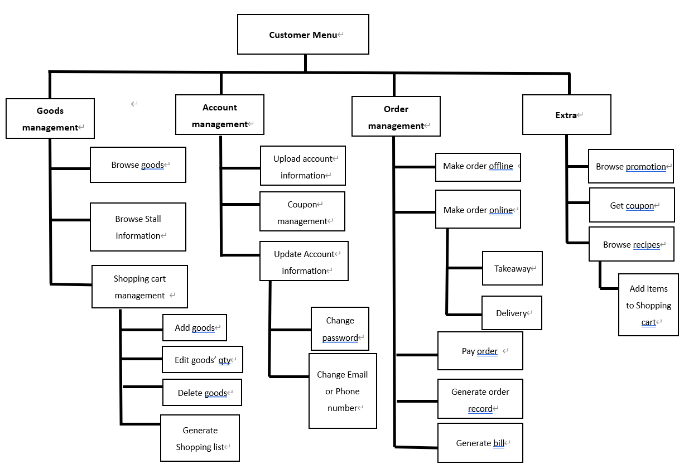

**10.1.2 Shopkeeper**

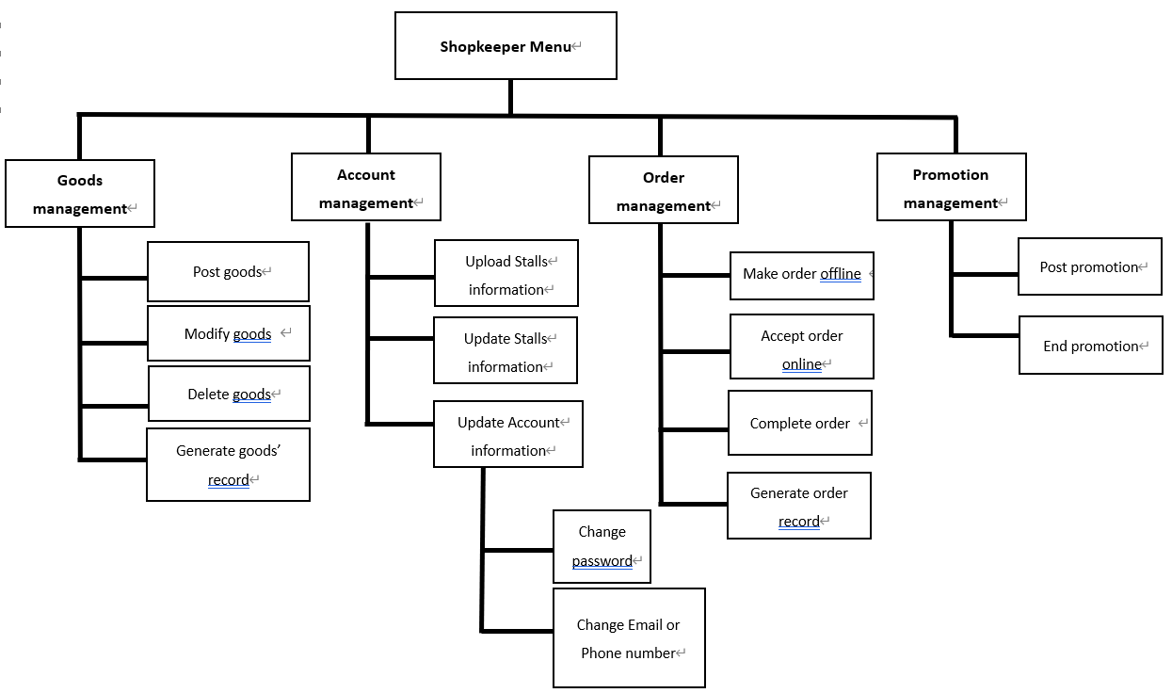

10.2 Network architecture

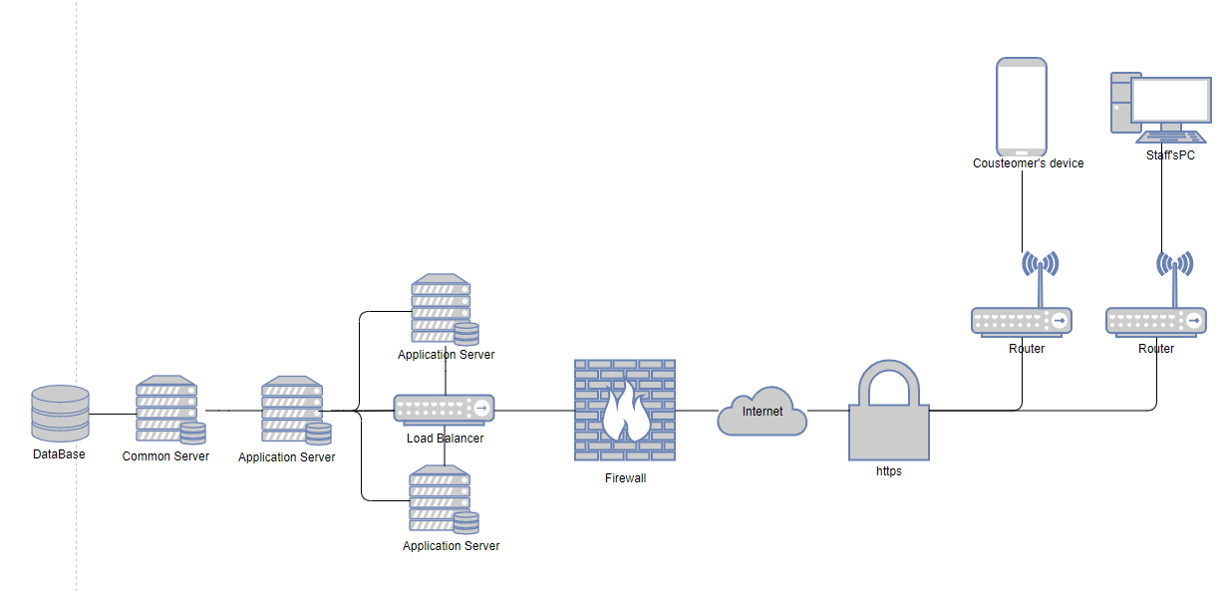

10.3 Intranet architecture

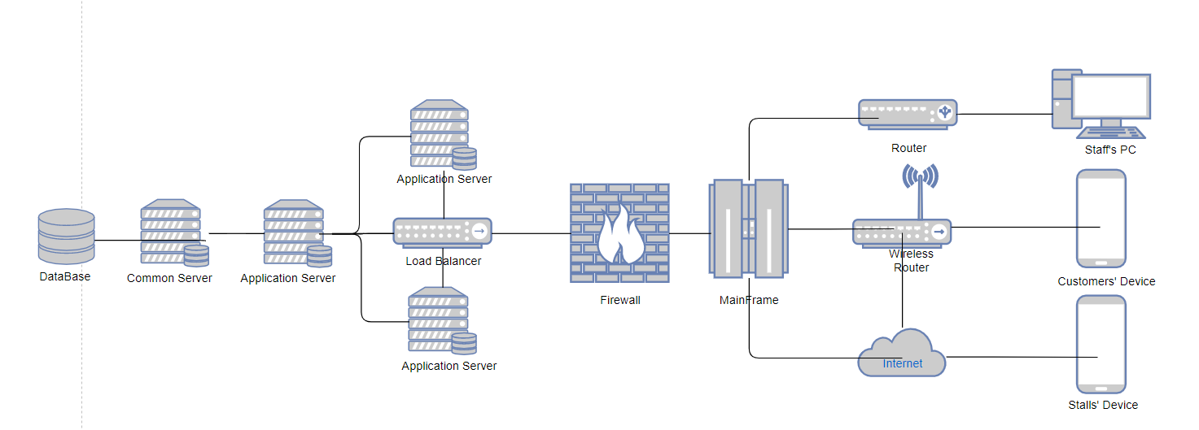

10.4 Hardware and software specification

|  |  |  |  |  |  |
| --- | --- | --- | --- | --- | --- |
|  | Database Server | Web Server | Application Server | Client | Client  (Mobile) |
| OS | Linux | Linux | Linux | Windows  Linux  Mac | Android |
| Hardware | Xeon® processor or AMD Opteron  30TB | Xeon® processor or AMD Opteron  5TB | Xeon® processor or AMD Opteron  600GB | Normal PC specification | Normal Android mobile phone specification |
| Network | 1GB | 1GB | 1GB | 100Mb | Minimal network |
| Software | Oracle SQL | Apache HTTP Server | Java |  |  |

11 Requirement specification

11.1 Class Diagram

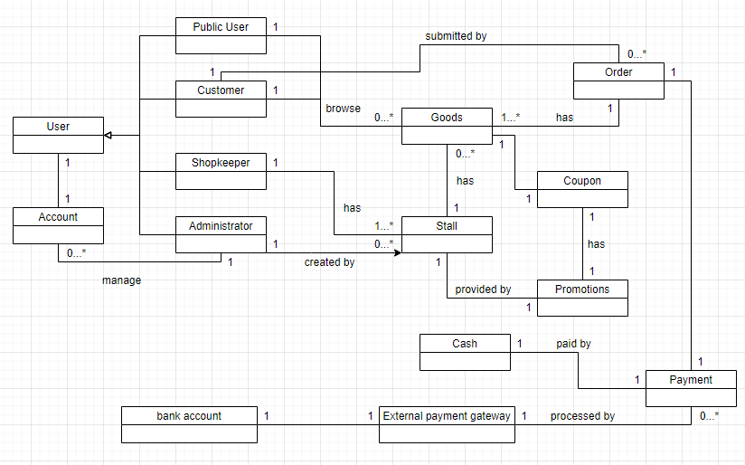

11.2 3-tier Sequence Diagrams

**11.2.1 Register successful**

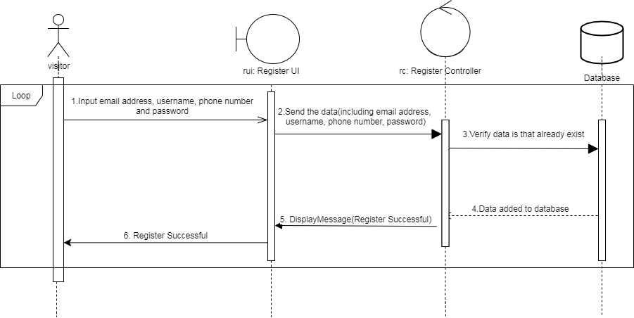

**11.2.2 Register unsuccessful**

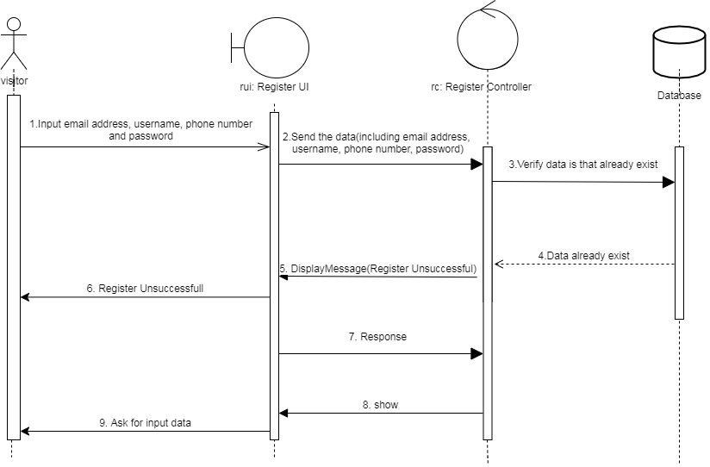

**11.2.3 Login successful**

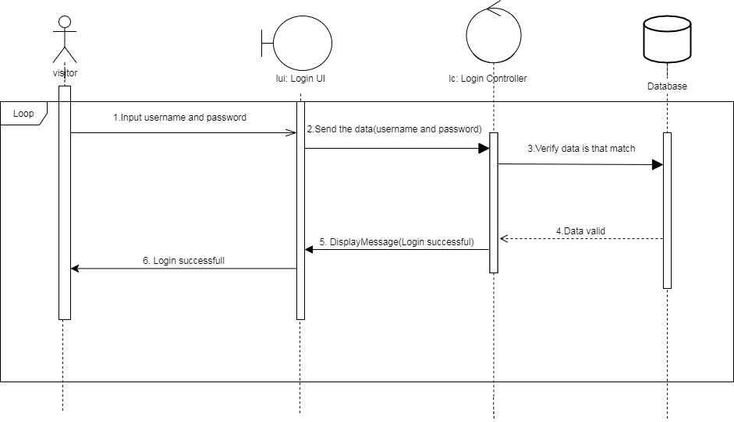

**11.2.4 Login unsuccessful**

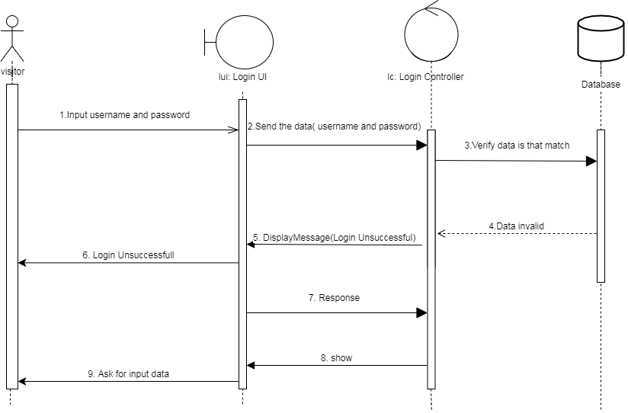

**11.2.5 Add goods to shopping cart (Customer)**

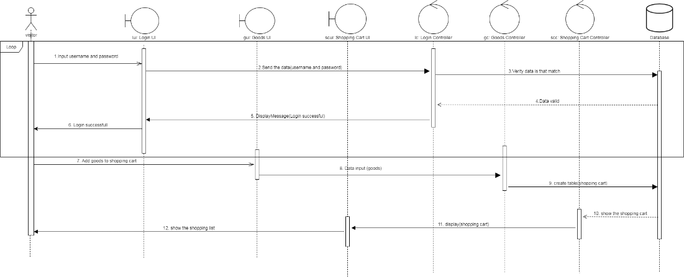

**11.2.6 Setting Coupon (Stall)**

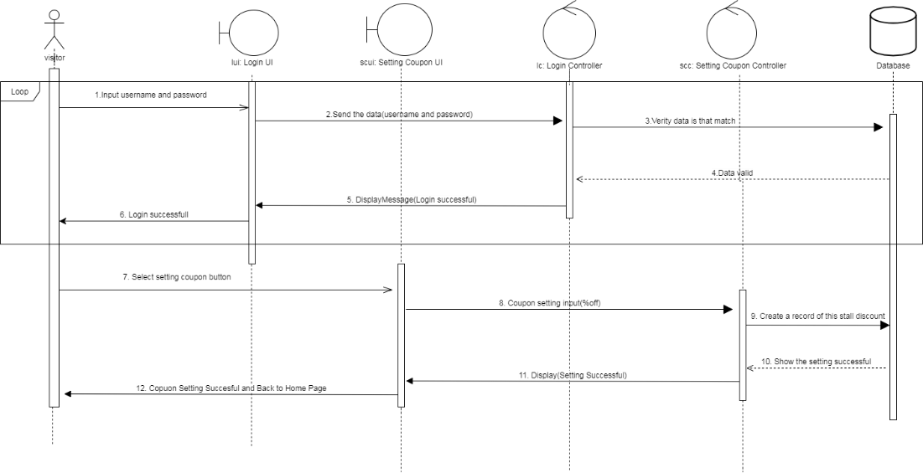

**11.2.7 Order (payment with QR code)(Web) (Customer)**

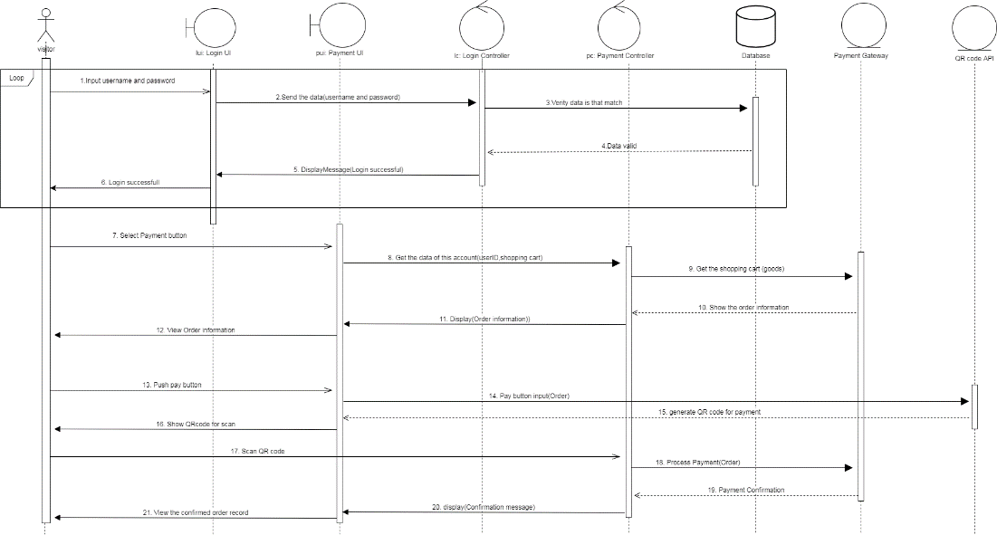

**11.2.8 Order ([payment with QR code)(Mobile App) (Customer)**

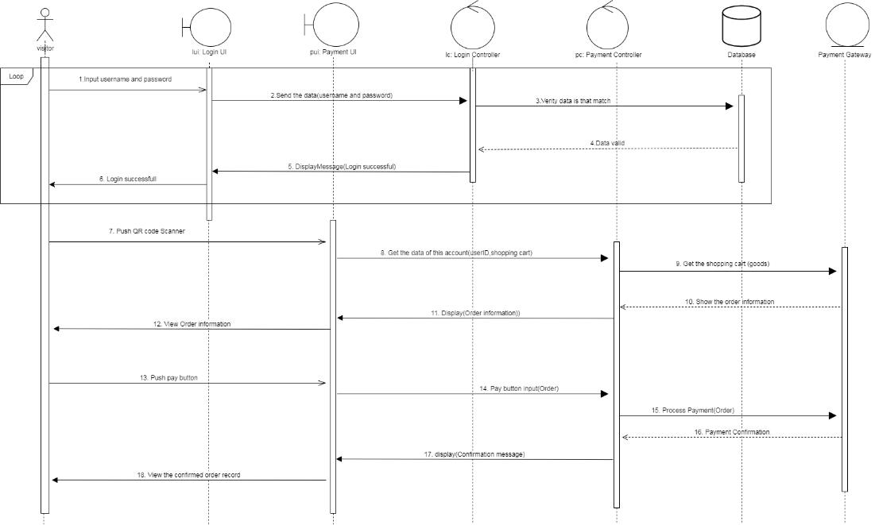

11.2.9 Order (payment with Credit card) (Customer)

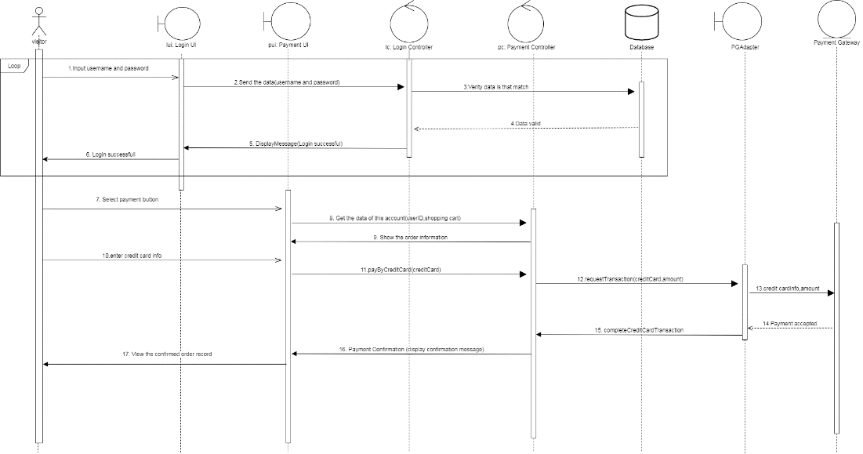

**11.2.10 Order record (Customer)**

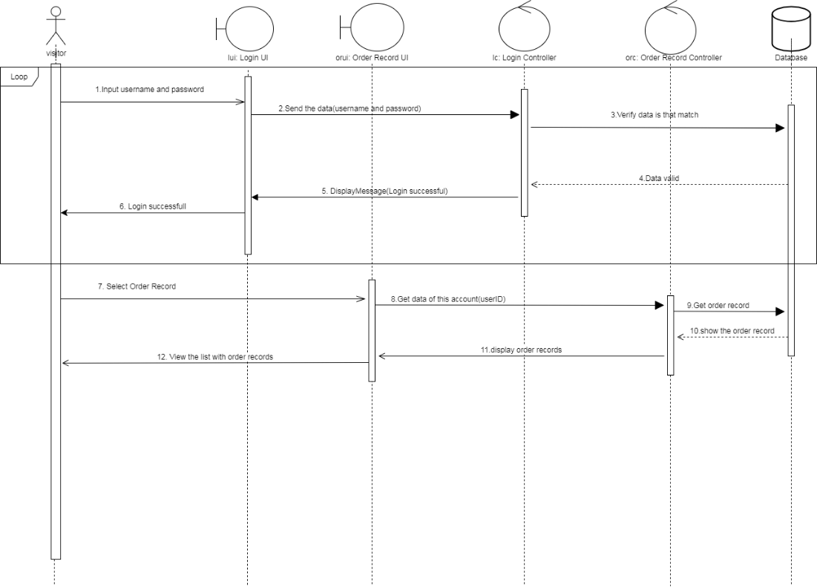

**11.2.11 Order List (Stall)**

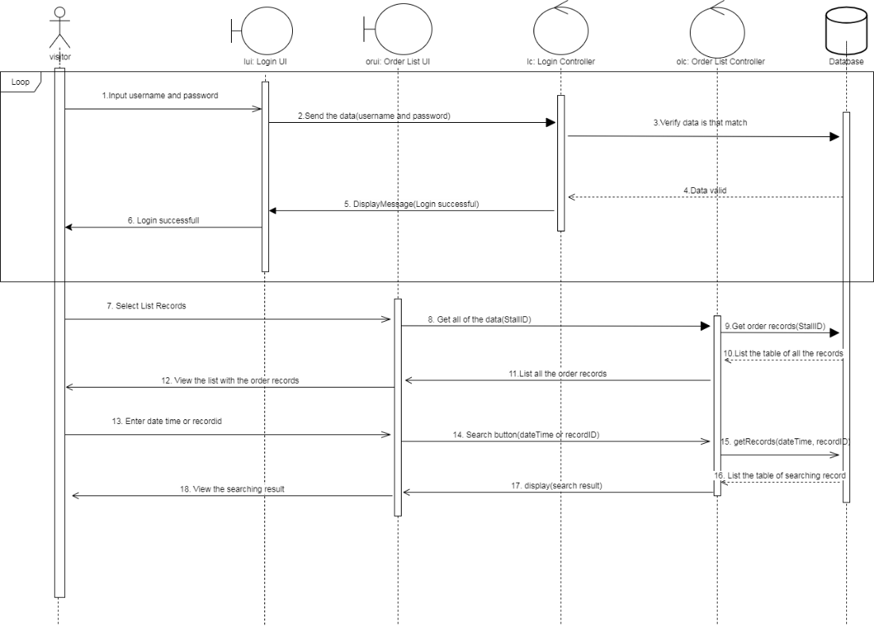

**11.2.12 Promotion Request (Stall)**

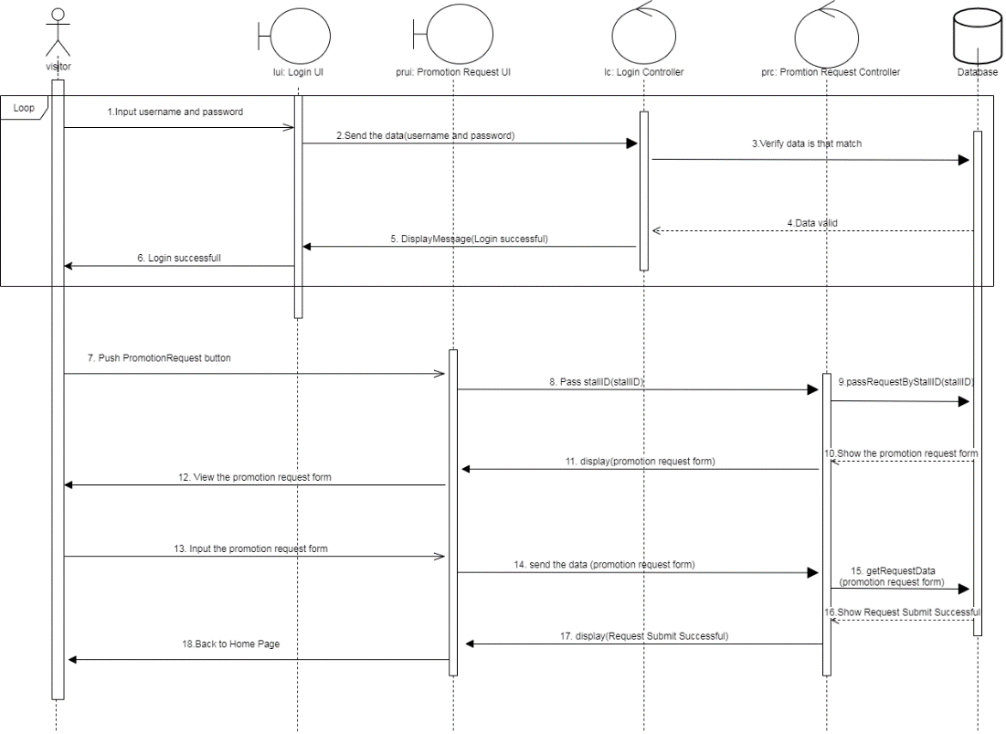

**11.2.13 Accept Promotion (Administrator)**

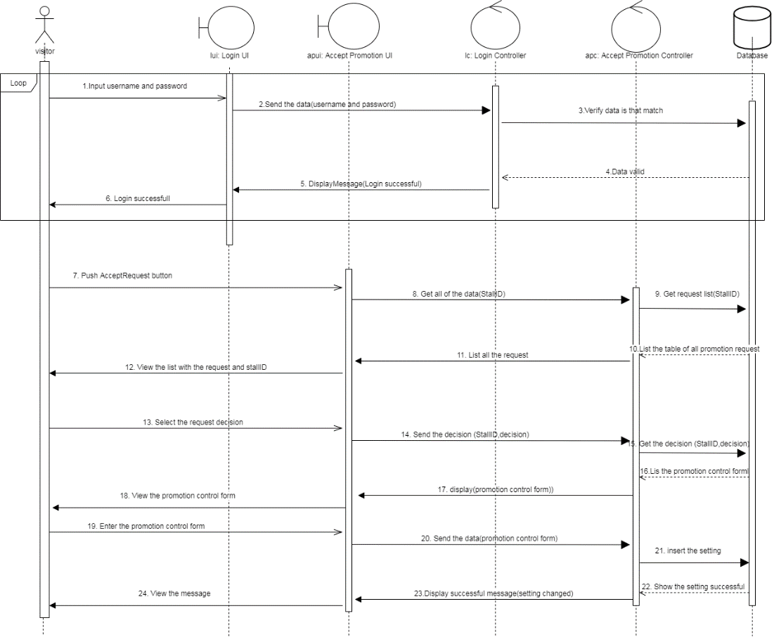

**11.2.14 Edit Personal Information (All Permission)**

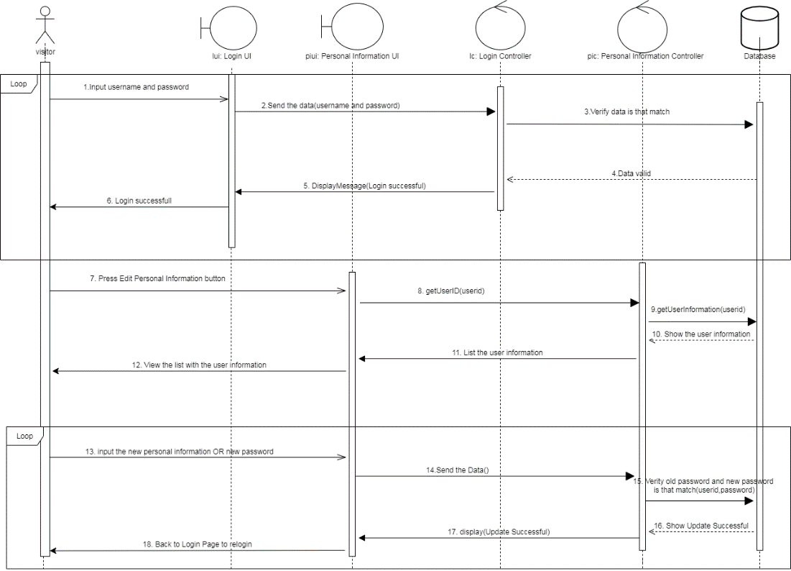

11.3 State Machine Diagrams

11.3.1 Login Controller (Login)

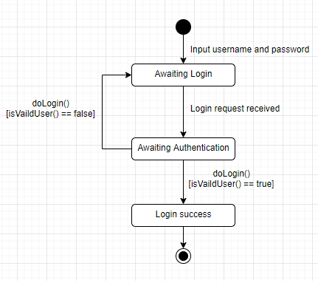

11.3.2 Order Controller (Processing order)

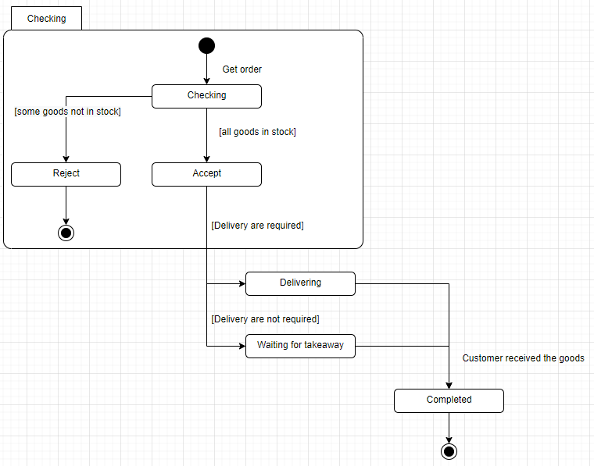

11.3.3 External Payment Gateway (Payment)

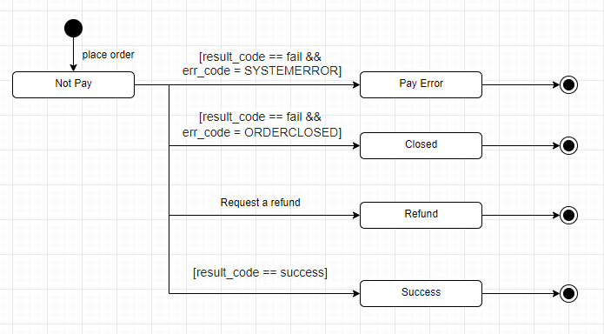

12 Critical evaluation

12.1 Problems/Difficulties Encountered

This project involves many parts, so we need to learn new knowledge by ourselves. For example, application server, payment gateways (PayPal, WeChat Pay, Alipay) and QR code recognition.

These programs and software have never been learned before, so we started from scratch. If our team members are not proficient in dealing with challenges and performing tasks, we will not be able to meet the requirements and schedule.

12.2 Delays/Changes in project Schedule

Our time is limited, and we will face a problem that we cannot devote the expected time to the project, nor can we meet the Gantt chart.

When we start coding, we will pop up some new ideas about the program or new features, and when we continue the project, it will be a little different from our prototype. For example, we want to use WeChat Pay to build a payment gateway system. But we don’t have more resources to build real resources, so we changed to use Alipay or PayPal to build a payment gateway.

It is also very difficult to use WeChat Pay, because it need to provide some real company supporting material to apply for using. Therefore, we will build a demo payment gateway system.

12.3 Limitation of the proposed system

Our project may need to build a server to support the functions of online and offline shopping. However, it is still difficult for us to build a server at this stage, so we can only create a demonstration to show our project. In the future, we will try our best to structure the server to achieve the expected results of the proposed plan.

12.4 Suggested progression Route

Now we knew the problem and reviewed our project immediately. We check the Gantt chart and analyze which parts have been completed and which parts are not ready for better project planning and tracking. We can't let us forget the original purpose and follow the top task of the project plan.

13 Detail project plan

13.1 Methodology

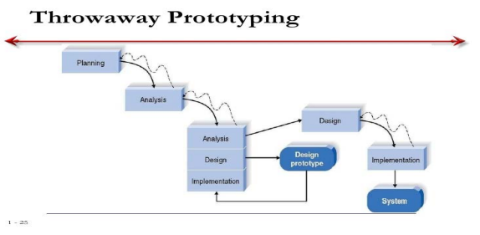

On developing Market Smart Buy, we adopt Throwaway

prototyping for developing the solution.

Throw-away prototyping is to create a part of the future application as soon as possible to ensure that a feature is technically feasible or to show the feature to stakeholders or potential users in order to collect feedback from them. Generally speaking, the most shopkeepers in the market have no experience in IT technology. Therefore, when we are dealing with stakeholders who have no technical background, and with tight deadlines and very limited resources, we are well suited to prevent risks.

13.2 Schedule

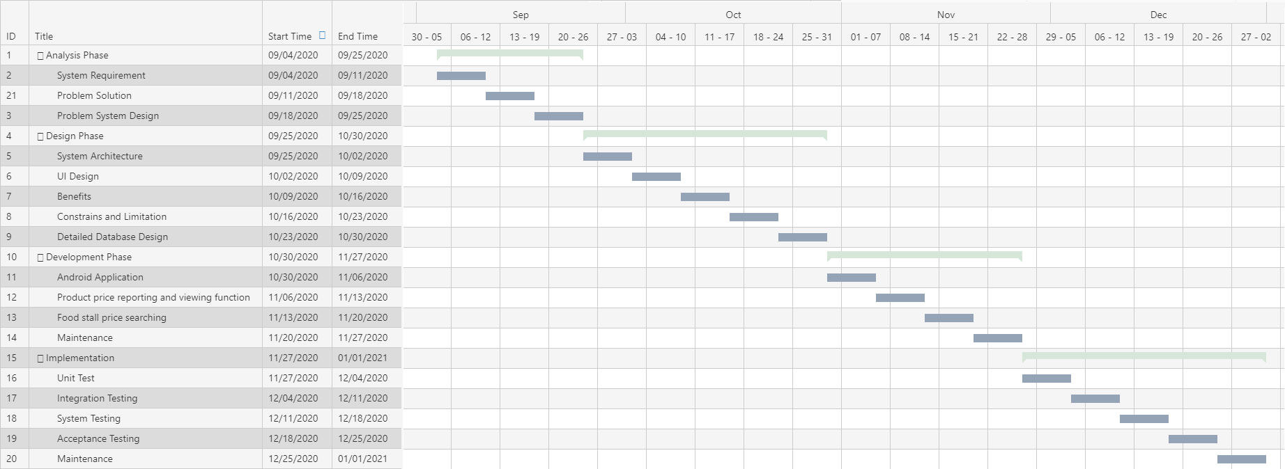

Main stages involved in the project, with estimated time to completion of each stage:

This is tentative time plan. It will be modified by case.

13.3 Deliverables

Main Deliverables:

1.System analysis and design

2.User interface

3.Software open source code

4.Implementation plan result

5.System spec

6.User guideline

In stage, 1: We expect to build-up the basic system application for use. Such as the main functionals and user-interfaces as a part of the system for the deliverable.

In stage, 2: We expect our system can be work and build-up all functionals and setting the parts of data use and system test to collect the data analyses a deliverable.

In stage 3: We expect to build up the data use and system test analysis application as a part of the system for the deliverable.

In stage 4: We expect to optimize the supporting function to make the system more integrity and fluency for the deliverable reduce the bug during in use of the application.

13.4 Software tools

1. Android Studio
2. Adobe Ai
3. Visual Studio Code
4. mySQL

13.5 Facilities and Hardware needed

Basically, we don't need any hardware except for the server. But we need to do some test on the android environment so we need a mobile phone or we may use a virtual machine on the computer to replace it.

13.6 Server Hardware Recommendation

Operating System: Linux OS

Hardware: Xeon® processor or AMD Opteron

Storage: 5TB or above(available space)

RAM: 32GB

# **14 User Interface Design**

14.1 Website

14.1.1 Home Page

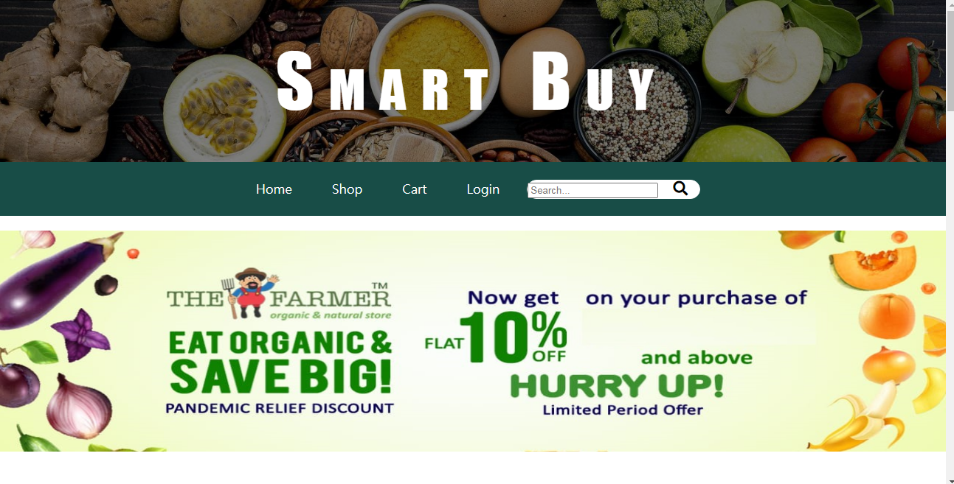

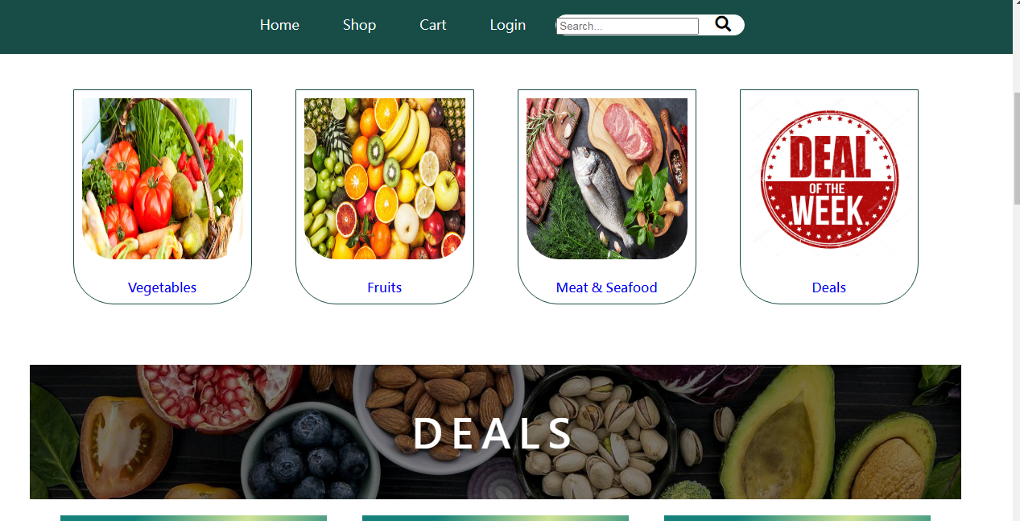

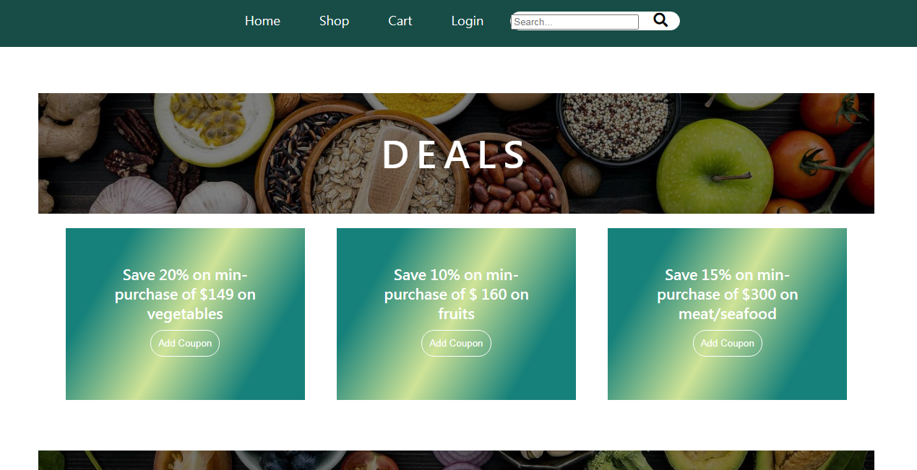

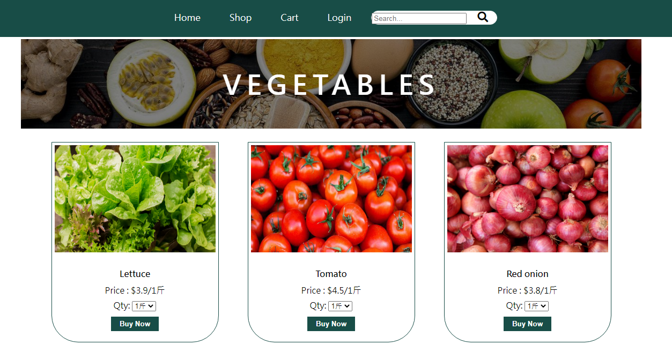

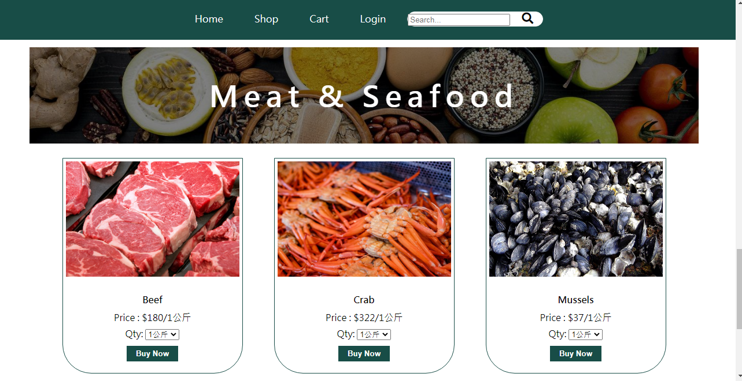

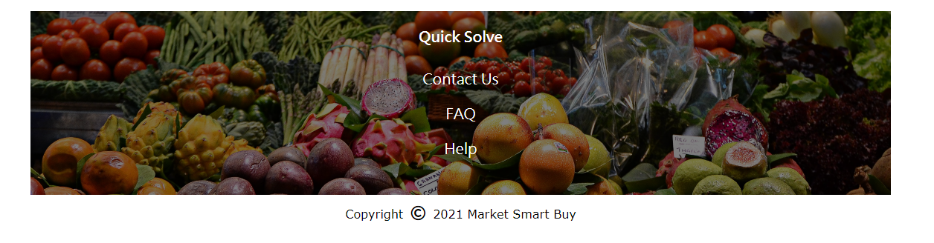

14.1.2 Shop List

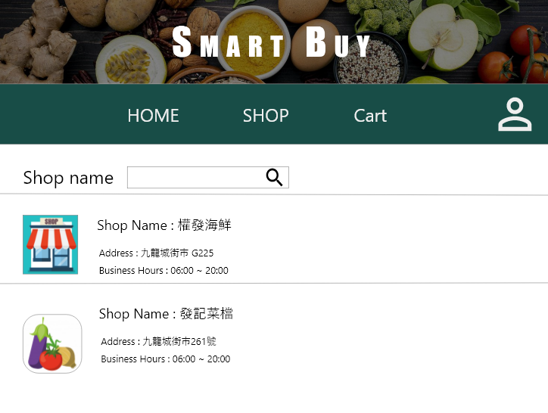

14.1.3 Login

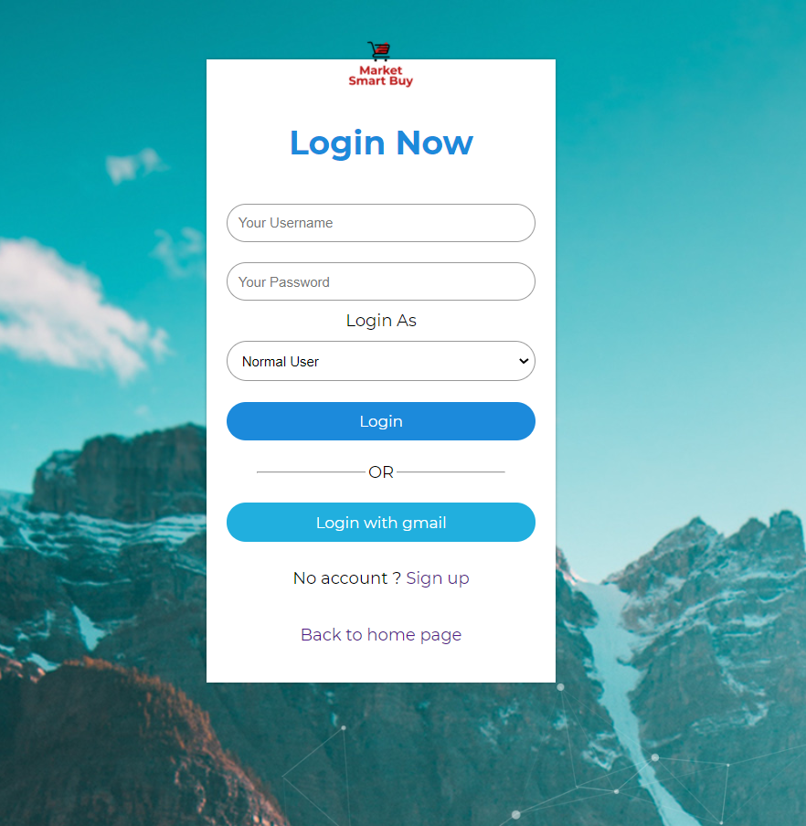

This the login page on the website for all users. Users enter the correct username, password and select which user type he/she would login as. System will check the data from the database to map the password and username. After login successful, the page will jump to the corresponding homepage. Users who don’t have an account can click Sign up to register a new account. Click the “Back to homepage” will jump to the homepage for public users.

### 14.1.4 Register

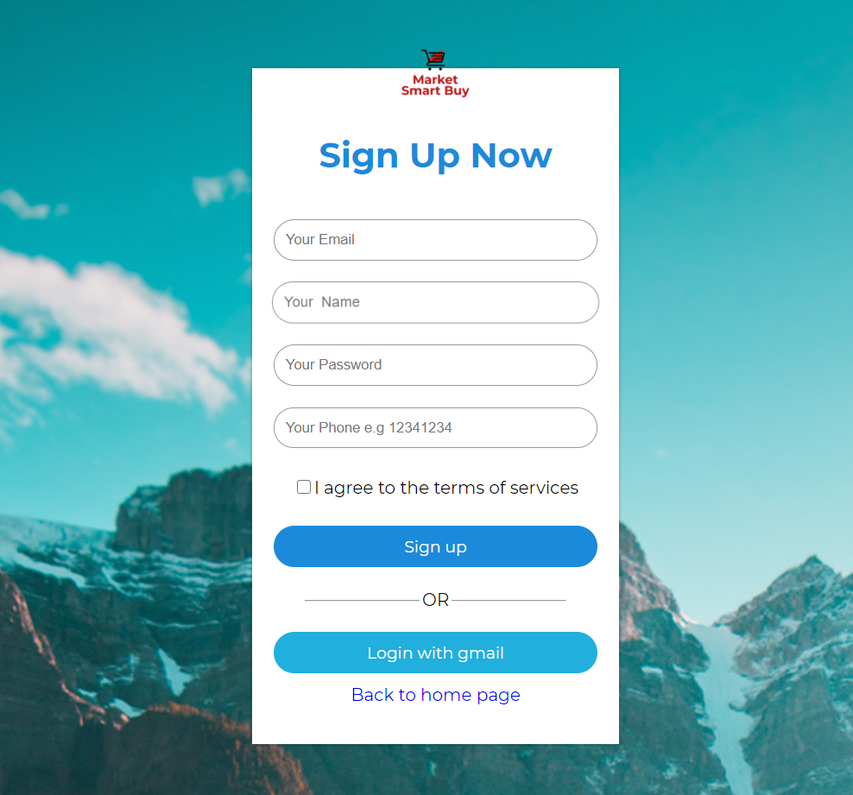

Public user should input correct Email address, name, password, phone number and click “Sign up” to register. Public user can only register a normal user account in this page.

### 14.1.5 Upload Product

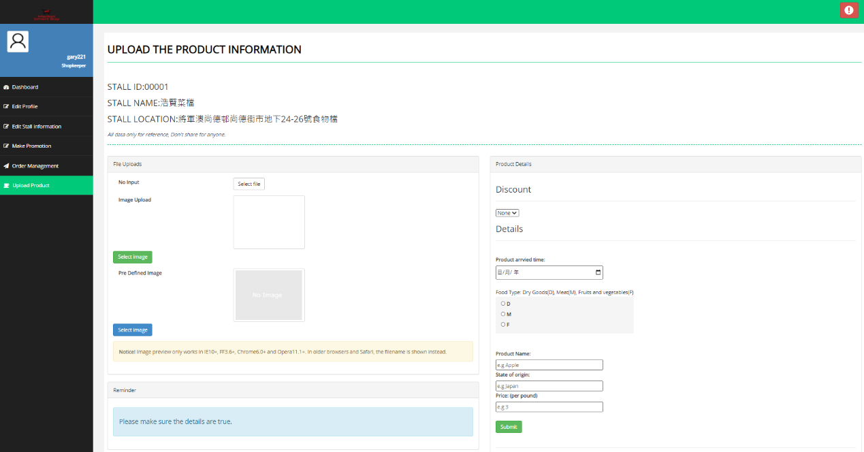

As a shopkeeper, this function is using to upload product of your stall. which can upload the image and typing the detail of the product such as setting discount, product arrived time, food type, product name, state of origin and price when you finish this form it will be uploaded into your stall page for the visitor to buy. But you should pre-login the shopkeeper account. If you don't have shopkeeper account is can't access into this page.

### 14.1.6 Promotion Request

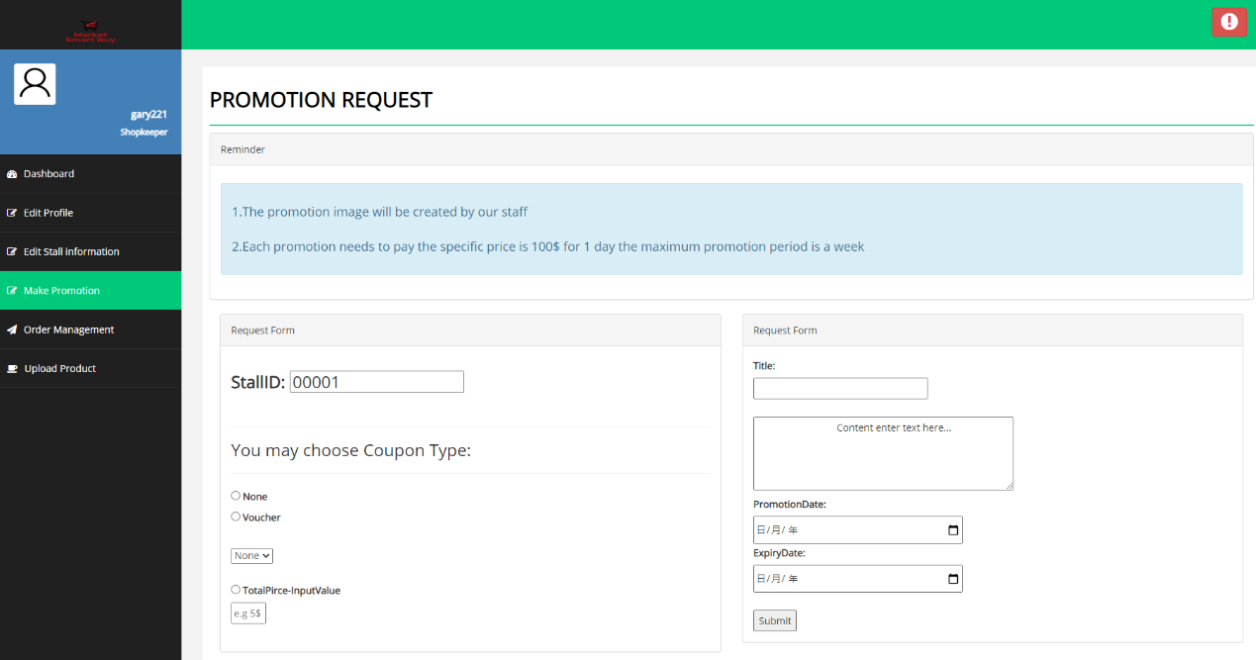

In this page, we can type the form to promote our stall in the home page, in the form we can select a different type of coupons such as 90% or total mount- your input number e.g. 500$-50$ as well as you can set the start period and expired period. But this request needs to wait to accept by staff because something promotion place maybe full.

### 14.1.7 Stall List

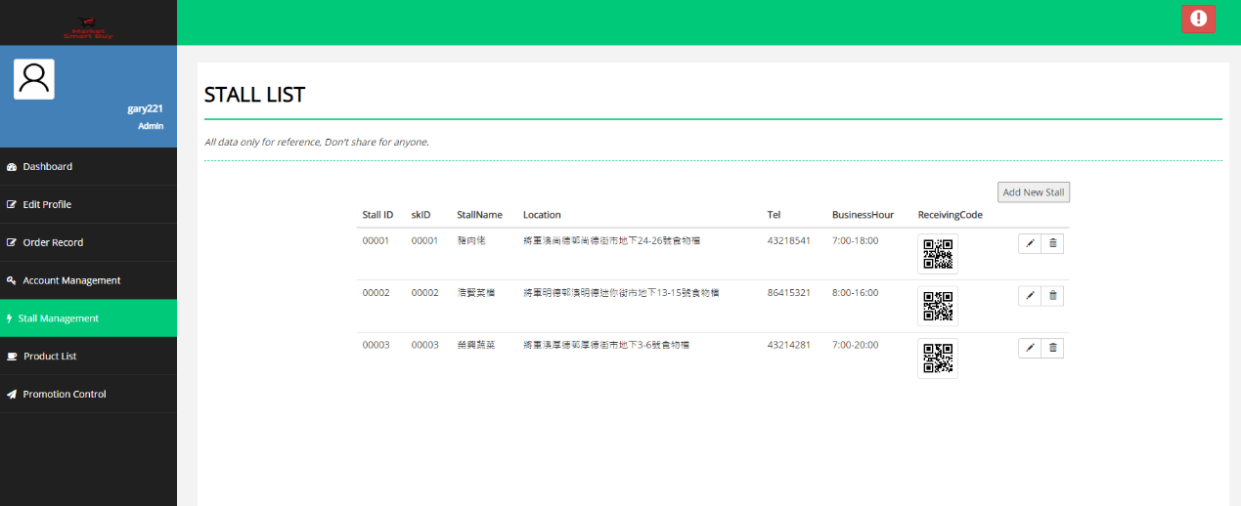

This page needs to admin permission to access, there are including all stall information such as stall name, location, tel. and payment code as well as admin can add new stall in this page.

### 14.1.8 Promotion Request Control

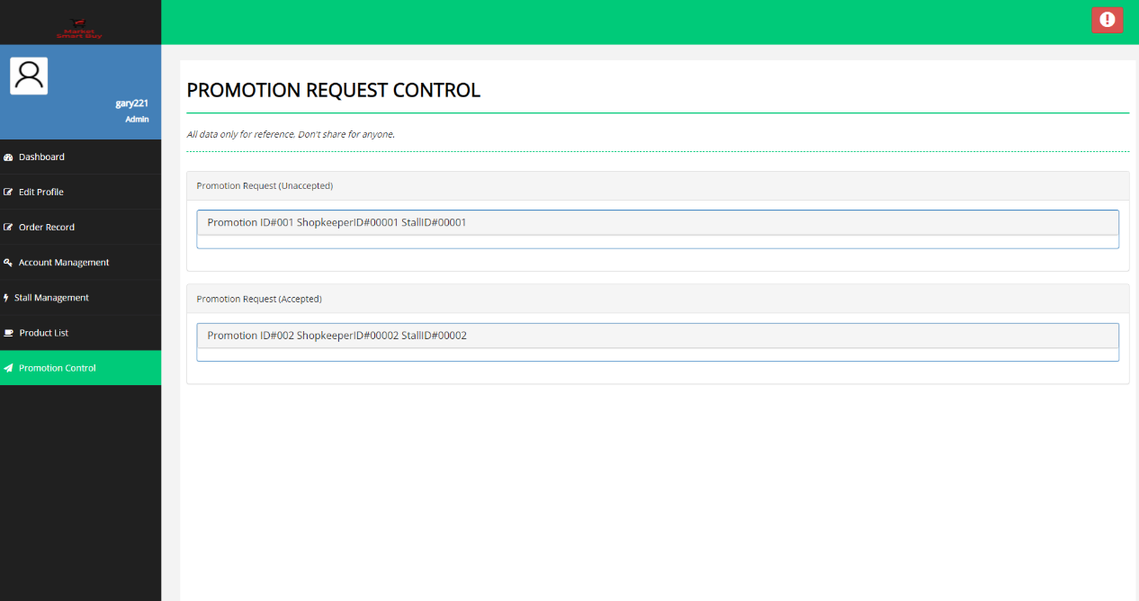

This page is using by admin to control and view which request has been accepted and unaccepted.

### 14.1.9 Promotion Accept Page

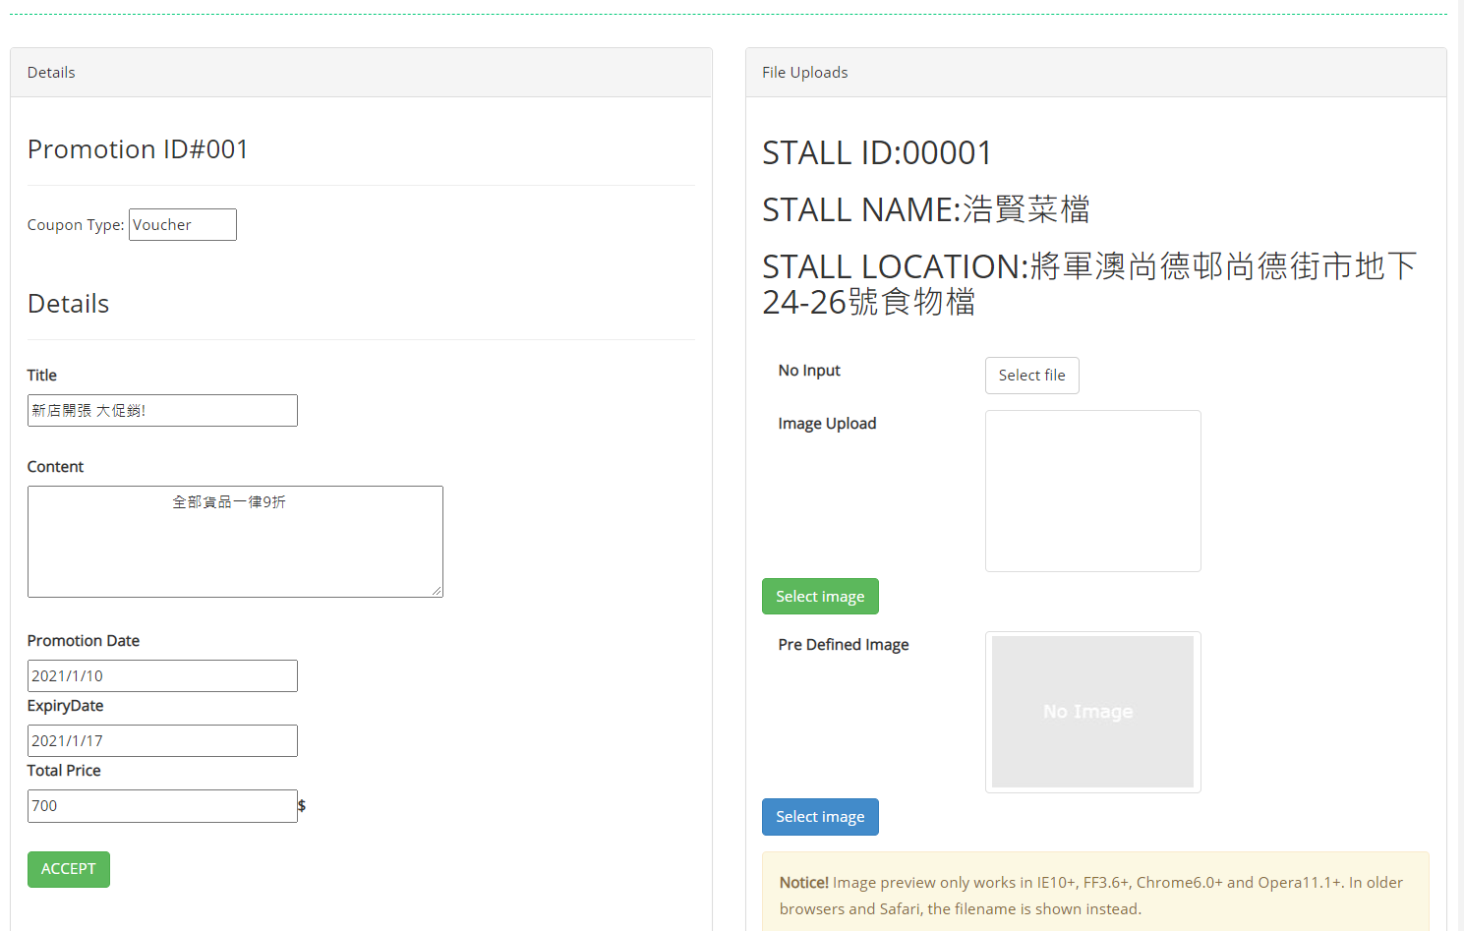

This page let the admin accept the promotion request and view the details of the request and help the stall to upload the image.

14.2 Mobile app

### 14.2.1 Menu Bar

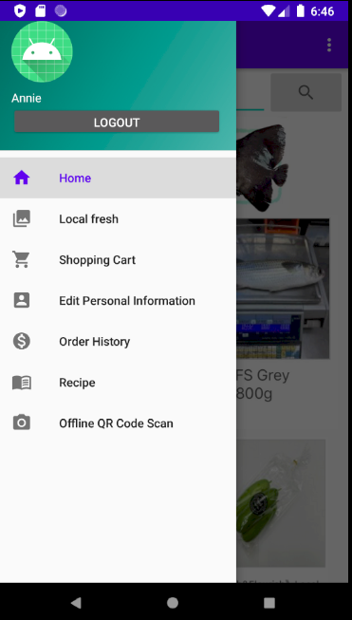

It is the navigation bar for user easy to access another page. The navigation bar is very common in others app. Users can easily understand the function of the bar and the operate method by icon or text. For example: the navigation bar is user- friendly for users easy to find the functions of this app.

### 14.2.2 Login

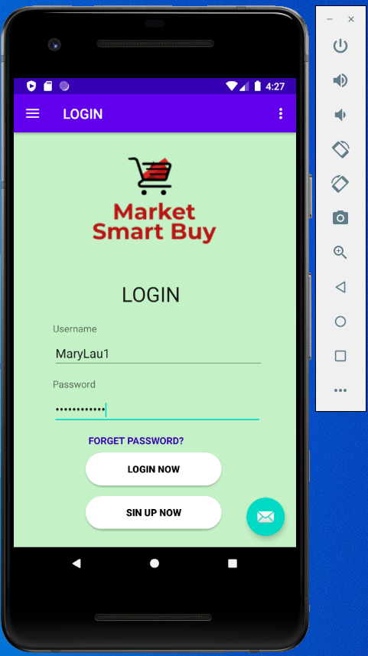

When users log in, they need to enter their Username and password. After the user needs to enter the “login now” button. If the user enters the wrong password, a warning message will be displayed. If the user input is correct, it will go to the Home page.

When enter the forgot password text, it will go to the forget password page. When user Click the Sign Up text, it will go to the Signup page.

### 14.2.3 Sign Up

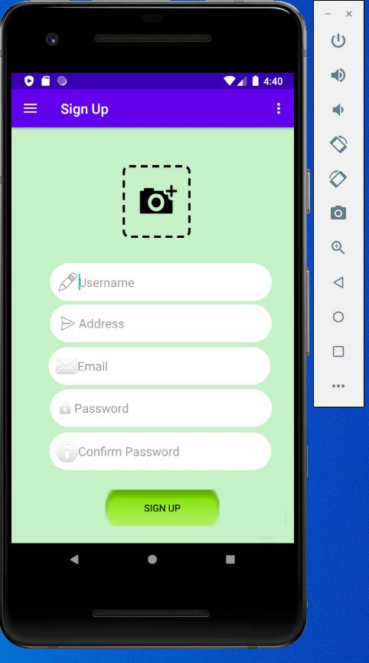

In the "Sign Up" page, User need to enter Username, shipping address , Email, Password and confirm the password, if the password and confirm password are not the same, the application will display a warning message. Before, if the Email had already registered, user cannot register a new account with this Email . After click the button (SIGN UP) to create an account.

### 14.2.4 Update Personal information

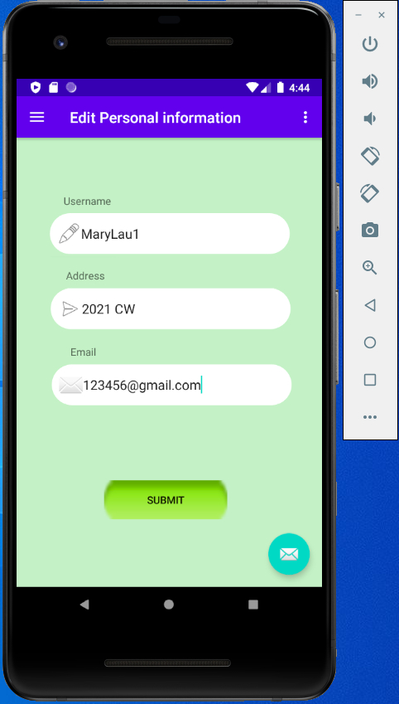

The update personal information only can change the Username, Address and Email.

### 14.2.5 History Record

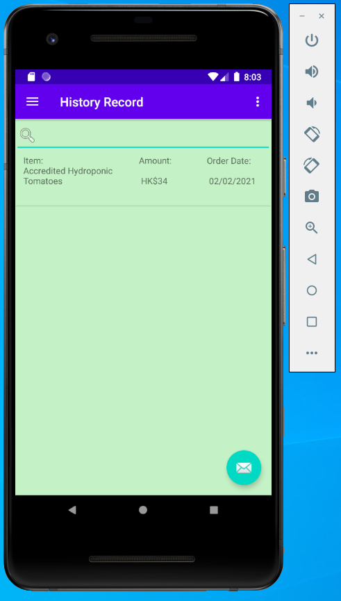

User can input the Item key word (tomato) to search the order record.

### 14.2.6 Logout



At first, the navigation bar will display username after users login the account.

The text button’s function can be presented directly to the user by its text. It's easy to find, because the logout text button is obviously a prompt for the user to log out of the account. Once user click on it, the session will be clean.

### 14.2.7 Home

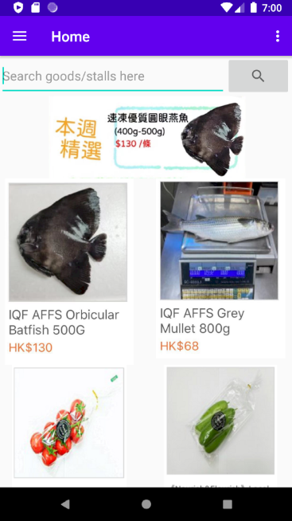

In Home page, user can search the goods or stalls by some keyword. There will be some promotion events showing to users at first. Besides, app will recommend some product with special offer and user can click on the product to view their details.

### 14.2.8 Local fresh

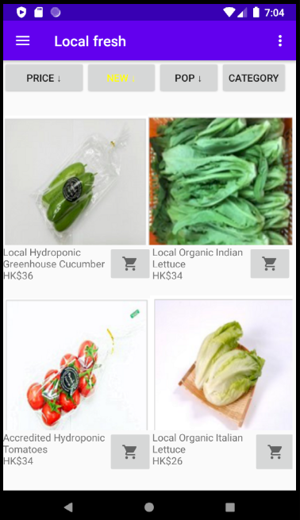

When users want to view some Local fresh, they can click the Local Fresh option on the navigation bar and the Local fresh page will display. It will display many products for user to select. User can click the button on the top, the product will be list by a certain order and the button will turn yellow to tell user the list has been sorted. User can click the shopping cart button to add the relate product to user’s shopping cart.

### 14.2.9 Shopping Cart

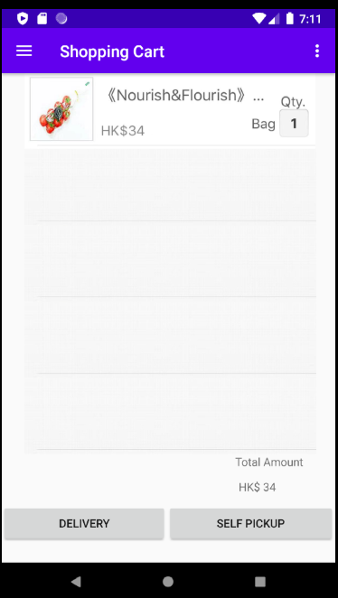

When users want to view their shopping cart, they can click the Shopping Cart option on the navigation bar and the Shopping Cart page will display. It will display many the items what the user added to shopping cart before. User can click the Edit text to change the quantity of the item. The Total Amount will be calculated automatically. Then, user can select “Delivery” or “Self Pickup” by click button with corresponding text to make order.

### 14.2.10 Make orders (1)

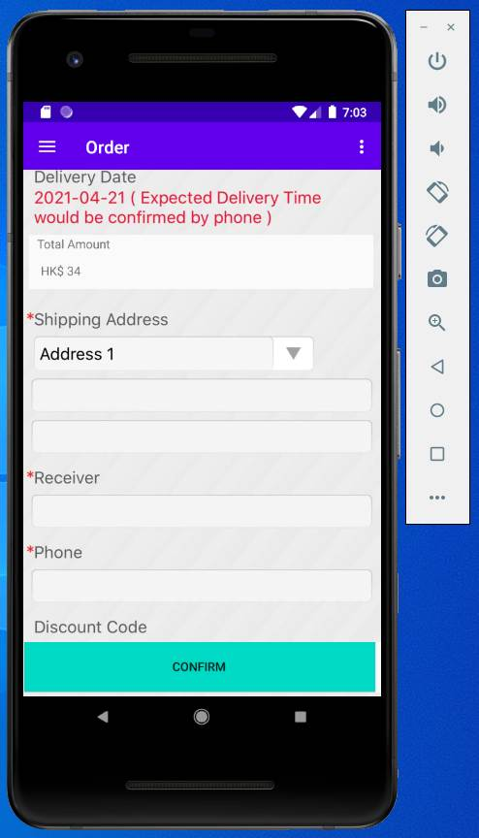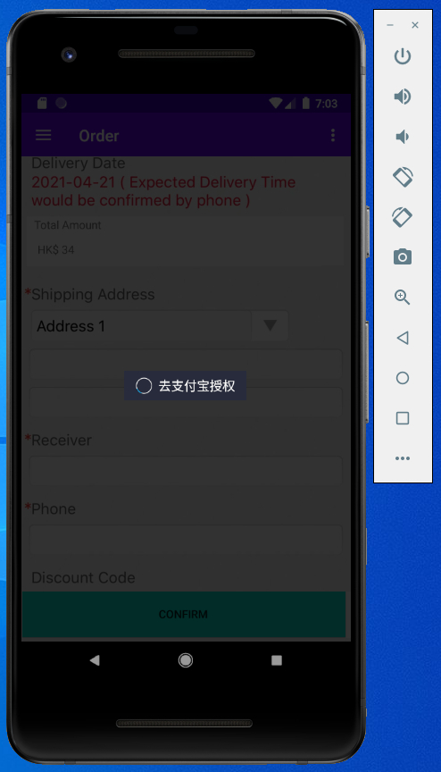

When the user decides to buy the items in the shopping cart, user should input more detail information Address, receiver and phone number to make an order.

The app will automatically jump to the Alipay payment page to complete the transaction.

### 14.2.11 Offline QR Code Scan

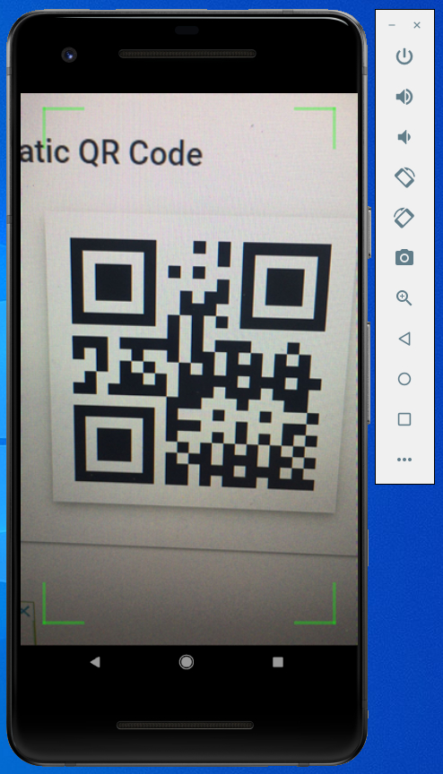

When users need to use app to purchase product offline, they should click the offline QU Code Scan option on the navigation bar and scan the QR code. It will redirect to external payment gateway to help user complete pay by phone.

### 14.2.12 Make order (2)

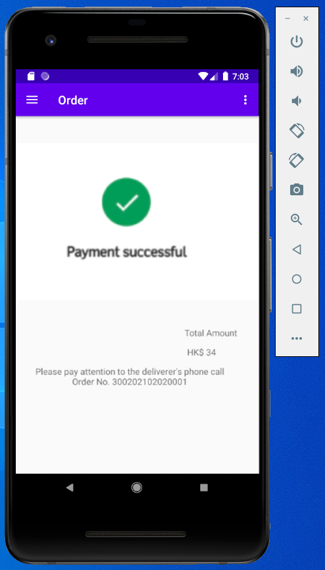

Finally, system will display a “Payment successful ” message and provide the bill. The bill has been provided amount and order ID.

15 Test Case

**15.1 Test Case(Web)**

|  |  |
| --- | --- |
| Test case ID | TC-Web-01 |
| Test case Description | User can login with valid username and password. |
| Pre-Conditions | The username and password are existing |
| Steps | 1. Go to login page  2. Enter the username and password  3. Click Login |
| Test data | Username: taiman01  Password: sktm01 |
| Expected result | The user will login as “Shopkeeper“ user group and direct to home page. |
| Postcondition | / |
| Actual result | The user login as “Shopkeeper“ user group and directed to home page. |
| Status | Pass |

|  |  |
| --- | --- |
| Test case ID | TC-Web-02 |
| Test case Description | User cannot login with invalid username and password |
| Pre-Conditions | The username and password are not existing |
| Steps | 1. Go to login page  2. Enter the username and password  3. Click Login |
| Test data | Username: invalidname  Password: invalidpw |
| Expected result | The error message will be shown on the login page. |
| Postcondition | / |
| Actual result | The error message is displayed on the login page. |
| Status | Pass |

|  |  |
| --- | --- |
| Test case ID | TC-Web-03 |
| Test case Description | Lock user account when they are inputting the wrong password for five times. |
| Pre-Conditions | The username is existing and the password is wrong. |
| Steps | 1. Go to login page  2. Enter the username and password  3. Click Login  If fail to login in step 3, go to step 1. |
| Test data | Username: taiman01  Password: invalidpw |
| Expected result | After 5 times failed logins, the user account will be locked. |
| Postcondition | / |
| Actual result | After 5 times failed logins, the user account was locked. |
| Status | Pass |

|  |  |
| --- | --- |
| Test case ID | TC-Web-04 |
| Test case | Register |
| Test case Description | Register a new client account with valid data |
| Pre-Conditions | / |
| Steps | 1. go to register page  2. Enter Email, Name, Password and Phone number field.  3. Click sign up |
| Test data | Email : [asdasd123@gmail.com](mailto:asdasd123@gmail.com)  Name : ChanTaiMan  Password : 654321  Phone : 9898 9898 |
| Expected result | A message box show up and display “Register Successfully!!” |
| Postcondition | / |
| Actual result | A message box show up and display “Register Successfully!!” |
| Status | Pass |

|  |  |
| --- | --- |
| Test case ID | TC-Web-05 |
| Test case | Change Password |
| Test case Description | Change account’s password after entering current password. |
| Pre-Conditions | User has an account. |
| Steps | 1. Enter current password  2. Enter new password |
| Test data | Account : ChanTaiMan  Current password : 654321  New password : 123456 |
| Expected result | A message box show up and display “Login Successfully !!  Welcome ChanTaiMan” |
| Postcondition | / |
| Actual result | A message box show up and display “Login Successfully !!  Welcome ChanTaiMan” |
| Status | Pass |

|  |  |
| --- | --- |
| Test case ID | TC-Web-06 |
| Test case | Order product |
| Test case Description | User with client account can select some products and add them into the shopping cart. Then order the products added into the shopping cart |
| Pre-Conditions | User login to a client account. |
| Steps | 1. Select some products  2. Go to shopping cart  3. Click order button |
| Test data | / |
| Expected result | A message box show up and display “Successfully Order!!” |
| Postcondition | / |
| Actual result | A message box show up and display “Successfully Order!!” |
| Status | Pass |

|  |  |
| --- | --- |
| Test case ID | TC-Web-07 |
| Test case | Edit account information |
| Test case Description | User with client account can select some products and add them into the shopping cart. Then order the products added into the shopping cart |
| Pre-Conditions | User login to a client account. |
| Steps | 1. Go to account profile page  2. Edit account information (phone number and email address)  3. Click modify |
| Test data | Phone : 9797 9797  Email : [abcdefg123@gmail.com](mailto:abcdefg123@gmail.com) |
| Expected result | A message box show up and display “Account information changed!” |
| Postcondition | / |
| Actual result | A message box show up and display “Account information changed!” |
| Status | Pass |

|  |  |
| --- | --- |
| Test case ID | TC-Web-08 |
| Test case | Sell goods |
| Test case Description | Shopkeeper post new products online with it’s type, name, price and quantity. |
| Pre-Conditions | User login to a shopkeeper account. |
| Steps | 1. Go to selling page  2. Choose the type of the product  3. Enter the name, price and quantity of the product.  4. Click sell button |
| Test data | Type : vegetable  Name : broccoli / kg  Price : 40  Quantity : 50 |
| Expected result | A message box show up and display “Goods successfully posted!” |
| Postcondition | / |
| Actual result | A message box show up and display “Goods successfully posted!” |
| Status | Pass |

|  |  |
| --- | --- |
| Test case ID | TC-Web-09 |
| Test case | Edit shop information |
| Test case Description | Shopkeeper editing their shop information including name, opening hour and status of the store. |
| Pre-Conditions | User login to a shopkeeper account. |
| Steps | 1. Go to Shop Management page  2. Edit information of the stall (Name, opening hour, and status)  3. Click modify |
| Test data | Name : IVE shop  Opening hour : 10:00 – 20:30  Status : Business as usual |
| Expected result | A message box shows up and display “Shop information changed!” |
| Postcondition | / |
| Actual result | A message box shows up and display “Shop information changed!” |
| Status | Pass |

|  |  |
| --- | --- |
| Test case ID | TC-Web-10 |
| Test case | Create promotional event |
| Test case Description | Shopkeeper post new products online with it’s type, name, price and quantity. |
| Pre-Conditions | User login to a shopkeeper account. |
| Steps | 1. Go to hold promotion page  2. Enter event title, content  3. If needed, add coupon and set the quantity of it.  4. Click Finish button |
| Test data | Title : 0% off  Content : 0% off when you purchase our products |
| Expected result | A message box shows up and display “Promotional event created!” |
| Postcondition | / |
| Actual result | A message box shows up and display “Promotional event created!” |
| Status | Pass |

|  |  |
| --- | --- |
| Test case ID | TC-Web-11 |
| Test case | Create shopkeeper account |
| Test case Description | Create shopkeeper account with username, password and create stall name, opening hour, location, status to create related stall. |
| Pre-Conditions | User login as a system admin. |
| Steps | 1. Enter username and password of shopkeeper account.  2. Enter stall name, opening hour and status of the shop.  3. Click create |
| Test data | Username : sk001  Password : sk001234  Stall Name : Fresh food  Opening hour : 10 : 30 – 18 : 00  Status : Business as usual |
| Expected result | A message box shows up and display “Shopkeeper account created!” |
| Postcondition | / |
| Actual result | A message box shows up and display “Shopkeeper account created!” |
| Status | Pass |

|  |  |
| --- | --- |
| Test case ID | TC-Web-12 |
| Test case | Create staff account |
| Test case Description | Create staff account with username, password. |
| Pre-Conditions | User login as a system admin. |
| Steps | 1. Enter username and password of staff account.  2. Click create |
| Test data | Username : staff001  Password : staff001234 |
| Expected result | A message box shows up and display “Shopkeeper account created!” |
| Postcondition | / |
| Actual result | A message box shows up and display “Shopkeeper account created!” |
| Status | Pass |

15.2 Test Case(Mobile application)

|  |  |
| --- | --- |
| Test case ID | TC-App-Login-01 |
| Test case | login the mobile apps |
| Test case Description | User can login the mobile apps |
| Pre-Conditions | User should already be registered |
| Steps | 1. Running “Smart Market Buy” apps.  2. Enter “MaryLau1” as Username .  3. Input “XXXXXXXX” as password.  4. Click“Login Now” button |
| Test data | Username : MaryLau1  Password : XXXXXXXX |
| Expected result | Login successful and get into the home page |
| Postcondition | / |
| Actual result | Login successful and get into the home page |
| Status | Pass |

|  |  |
| --- | --- |
| Test case ID | TC-App-Register-02 |
| Test case | Create user account |
| Test case Description | User can create an account |
| Pre-Conditions | / |
| Steps | 1. Click “SIGNUP NOW”  2. Click the image icon to upload user picture.  3. Input username, address,  , email, password, confirm password.  4. Click “submit”. |
| Test data | Username : MaryLau2  Address : 2022 CW  Email : 1234567@gmail.com  Password : XXXXXXXX  Confirm Password : XXXXXXXX |
| Expected result | A message box shows up and display “Account Created!” |
| Postcondition | / |
| Actual result | A message box shows up and display “Account Created!” |
| Status | Pass |

|  |  |
| --- | --- |
| Test case ID | TC-App-ResetPwd-03 |
| Test case | Reset user account password. |
| Test case Description | User can reset account password. |
| Pre-Conditions | User should already be registered |
| Steps | 1. Click “Forget password”  2. Input Username and Email  3. Click “Submit”  4. Check if the email and username are matching or not.  5. If the email and username are matching.  6. Then input new password and confirm password.  7. New password will be reset. |
| Test data | Username : MaryLau1  Email : 123456@gmail.com  Password : XXXXXXXX  Confirm Password : XXXXXXXX |
| Expected result | A message box shows up and display “Password reset complete!” |
| Postcondition | / |
| Actual result | A message box shows up and display “Password reset complete!” |
| Status | Pass |

|  |  |
| --- | --- |
| Test case ID | TC-App-UpdateInfo-04 |
| Test case | Update user‘s personal information |
| Test case Description | User can edit user’s personal information |
| Pre-Conditions | Account should already be login |
| Steps | 1. Click the Menu button.  2. Click “Edit Personal Information”.  3. Input Username, address and Email  3. Click “Submit” |
| Test data | Username : MaryLau1  Address : 2022 CW  Email : 123456@gmail.com |
| Expected result | A message box shows up and display “Update Successful!” |
| Postcondition | / |
| Actual result | A message box shows up and display “Update Successful!” |
| Status | Pass |

|  |  |
| --- | --- |
| Test case ID | TC-App-HistoryReview-05 |
| Test case | Search and review transaction record |
| Test case Description | User can Search and review transaction record |
| Pre-Conditions | Account should already be login |
| Steps | 1. Click the Menu button.  2. Click “Order History”.  3. Input keyword into search box |
| Test data | Keyword: tomato |
| Expected result | It will display the transaction record with specific detail information such as “Amount”  or “Order Data”. |
| Postcondition | / |
| Actual result | It will display the transaction record with specific detail information such as “Amount”  or “Order Data”. |
| Status | Pass |

|  |  |
| --- | --- |
| Test case ID | TC-App-AddShoppingCart-06 |
| Test case | Add items to Shopping Cart |
| Test case Description | User can add items to Shopping Cart |
| Pre-Conditions | Account should already be login |
| Steps | 1. Click the Menu button.  2. Click “Recipe”.  3. Select a recipe  4. Click the button “ADD ALL TO SHOPPING CART” |
| Test data | Recipe: Half Catty |
| Expected result | A message box shows up and display “Ingredients already added to shopping cart!” |
| Postcondition | / |
| Actual result | A message box shows up and display “Ingredients already added to shopping cart!” |
| Status | Pass |

|  |  |
| --- | --- |
| Test case ID | TC-App-MakeOrder-07 |
| Test case | Make transaction |
| Test case Description | User can Make transaction |
| Pre-Conditions | Account should already be login and add some items to shopping cart |
| Steps | 1. Click the Menu button.  2. Click “Shopping Cart”.  3. Choose shipping method “Delivery” or “Self Pickup”  4. Input Address details, receiver, and phone number.  5. Go to Alipay to pay |
| Test data | Shipping method: “Delivery”  Address : 2021 CW  Receiver : Mary Lau  Phone number: 87654321 |
| Expected result | It will display a “Payment successful” message and show the order details and order ID. |
| Postcondition | / |
| Actual result | It will display a “Payment successful” message and show the order details and order ID. |
| Status | Pass |

16 User guide

16.1 Website (public user)

### 16.1.1 Search Ingredient

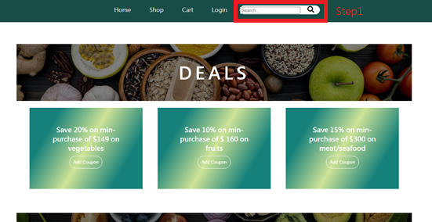

Step1 : Enter the ingredient name

Step2 : Press Enter

Step3 : The eligible results will be shown

### 16.1.2 Login



Step1 : Fill in the username and password

Step2 : Select user type

Step3 : Click the “Login” button

### 16.1.3 Register a normal user account



Step1 : Fill in the form

Step2 : Tick the check box “I agree to the terms of services”

Step3 : Click the button “Sign up”

16.2 Control Panel (Shopkeeper & Admin)

### **16.2.1** Upload product(Shopkeeper)



Step1 : Fill in the form

Step2 : Click “Select image” button to upload product image

Step3 : Click “Submit” button

### 16.2.2 Upload product(Shopkeeper)



Step1 : Fill in the form

Step2 : Click “Submit” button

### 16.2.3 Add new stall(Admin)



Step1 : Click “Add New Stall” button

Step2 : A form will be display and require the information of the stall

Step3 : Fill in the form and click submit.

### 16.2.4 Accept promotion request



Step1 : Click the text below Promotion Request (Unaccepted)

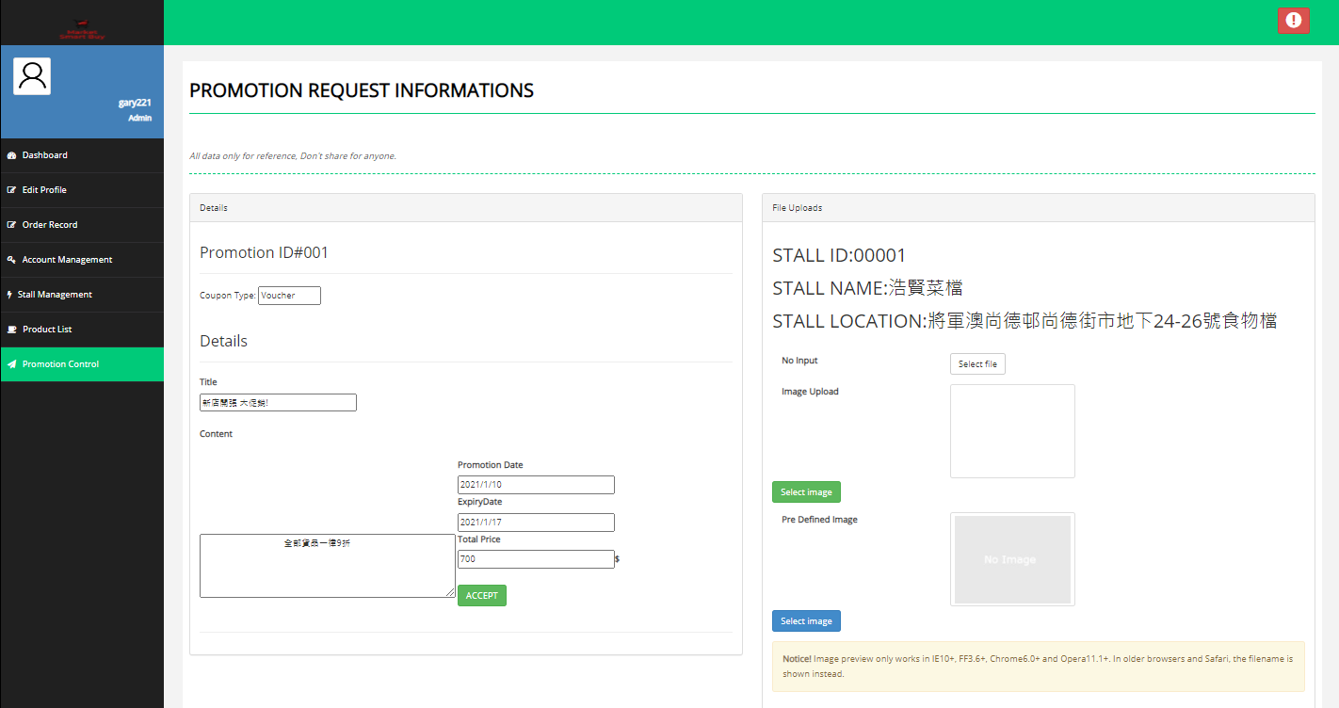

Step2 : Fill in the form and upload an image for promotion

Step3 : Click “ACCEPT” Button

16.2.5 Shopping Cart (Order with paypal)

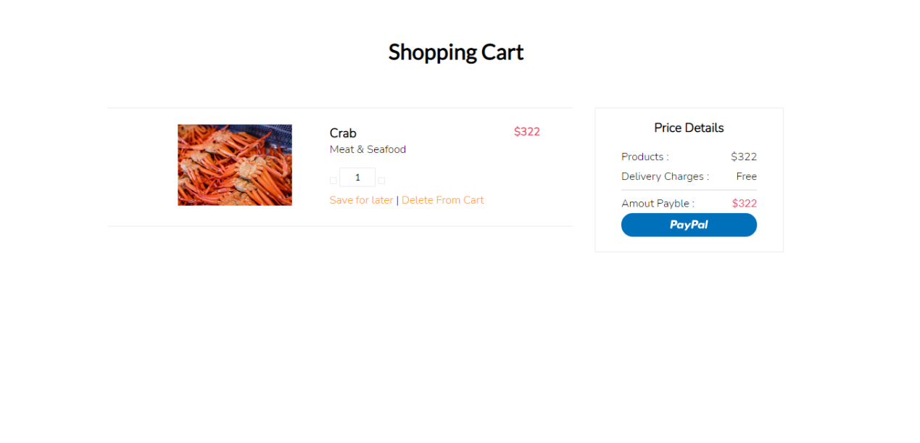

Step1: Check the order status

Step2: Click the PayPal button

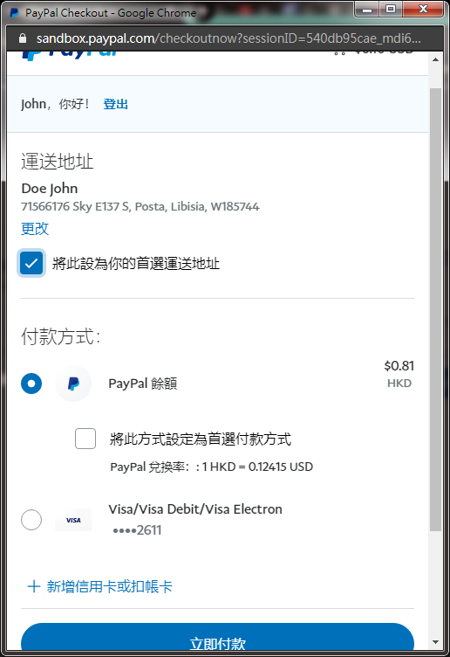

Step 1: Check your personal information is that correct. (If you have been logged in PayPal in your computer of the early time it will not be login again)

Step 2: Click pay button

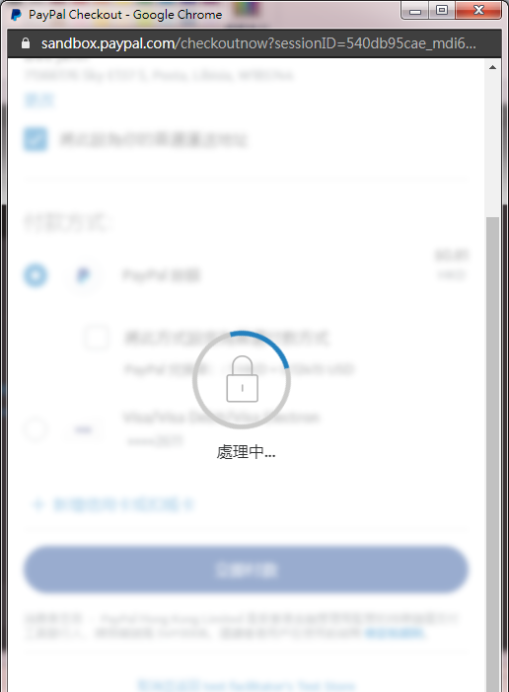

It will show the message "payment is in progress".



If the payment process is successful, it will show the successful message. And debit the balance from your PayPal account.

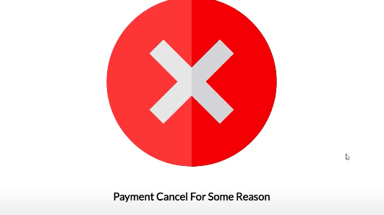

If the payment progress is rejected, it will show the payment cancel and turn the page back.

16.3 Mobile System (Customer)

16.3.1 Sign up



**Step1**

Step1: Click the button (SIGEUP NOW).



**Step7**

**Step6**

**Step5**

**Step4**

**Step3**

**Step2**

**Step1**

Step 1: Input a picture

Step 2: Input your Username (MaryLau1)

Step 3: Input your Shipping Address (2021 CW)

Step 4: Input the Email (123456@gmail.com)

Step 5: Input the password (XXXXXXXX)

Step 6: Input the password again to confirm (XXXXXXXX)

Step 7: Click the button (SIGN UP)

16.3.2 Login



**Step3**

**Step2**

**Step1**

Step1: Input your Username (MaryLau1)

Step2: Input your password (XXXXXXXX)

Step3: Click the button (Login Now)

16.3.3 Home Page

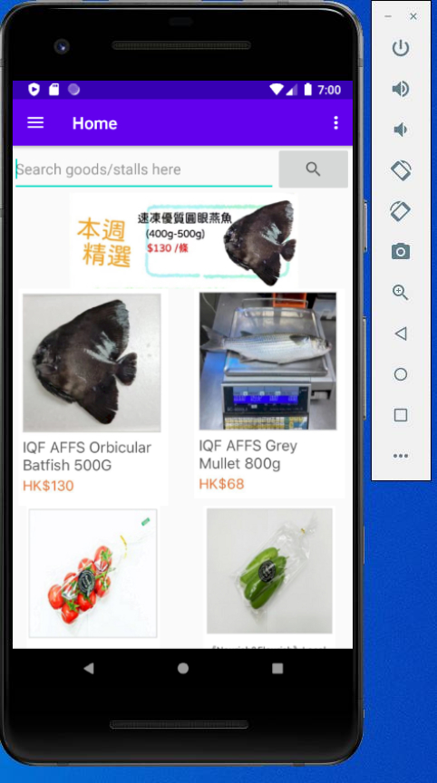

In Home page, user can search the goods or stalls by some keyword.

There will be some promotion events showing to users at first. Besides, app will recommend some product with special offer and user can click on the product to view their details.

16.3.4 Search for Ingredients

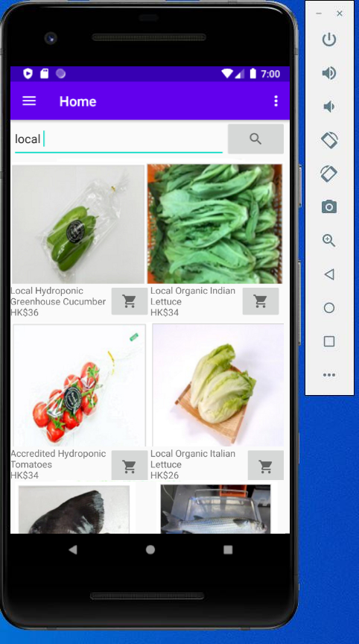

**Step1**

Step 1: Input some keyword to search.

16.3.5 Function Menu

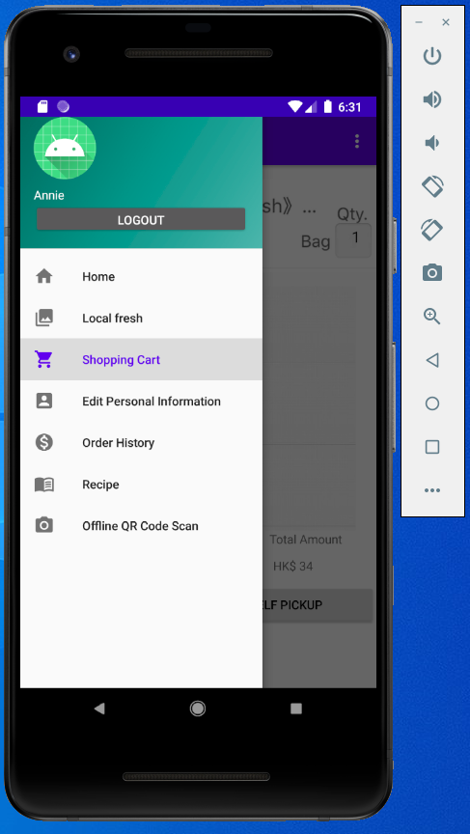

16.3.6 Edit personal Information



**Step2**

**Step4**

**Step3**

**Step1**

Step1: Input new Username (MaryLau1).

Step2: Input new Address (2021 CW).

Step3: Input new Email (123456@gmail.com).

Step4: Click the button (Submit).

16.3.7 Recipe

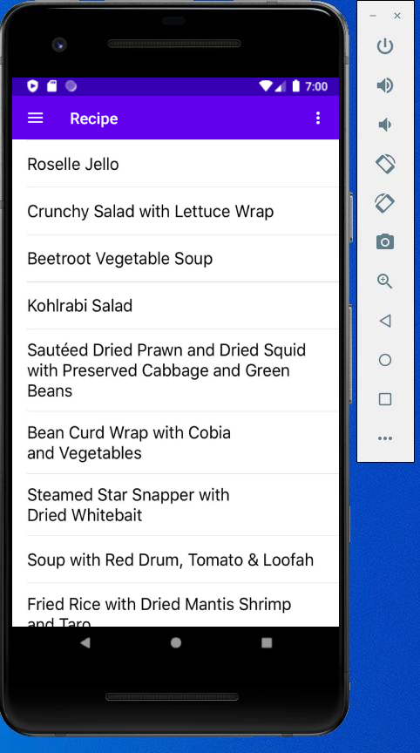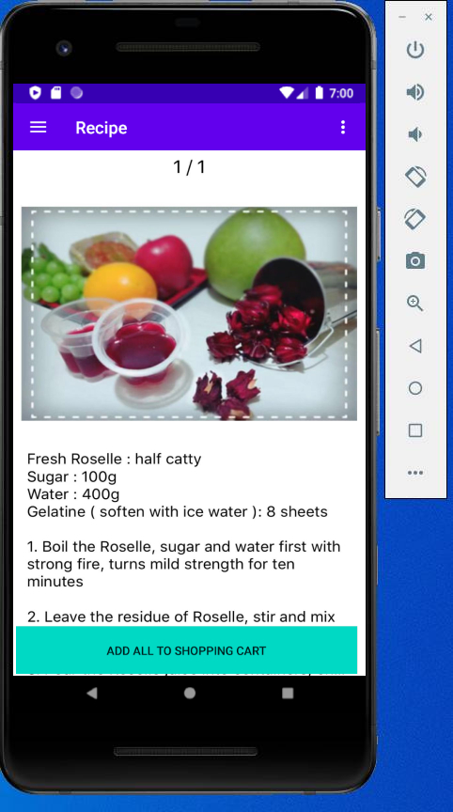

**Step2**

**Step1**

Step 1: Select a recipe.

Step 2: User can add the Ingredients to shopping cart by clicking the button (ADD ALL TO SHOPPING CART).

16.3.8 Local Fresh

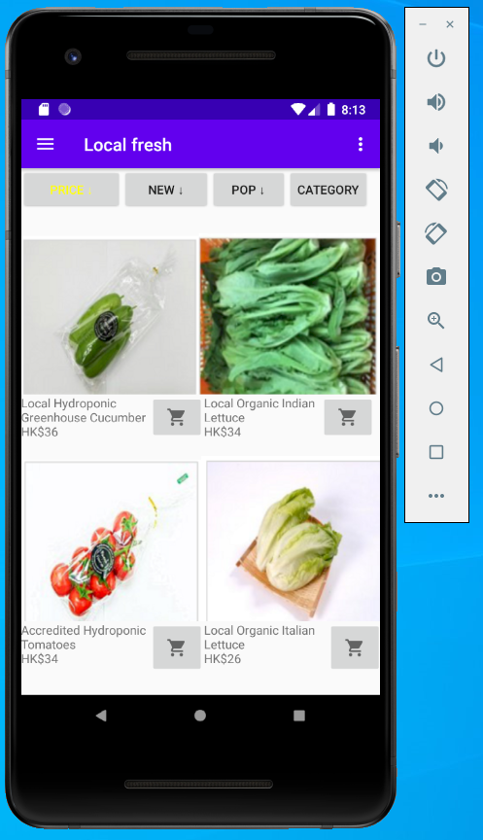

When users want to view some Local fresh, they can click the Local Fresh option on the navigation bar and the Local fresh page will display. It will display many products for user to select. User can click the button on the top, the product will be list by a certain order and the button will turn yellow to tell user the list has been sorted. User can click the shopping cart button to add the relate product to user’s shopping cart.

16.3.9 Shopping Cart

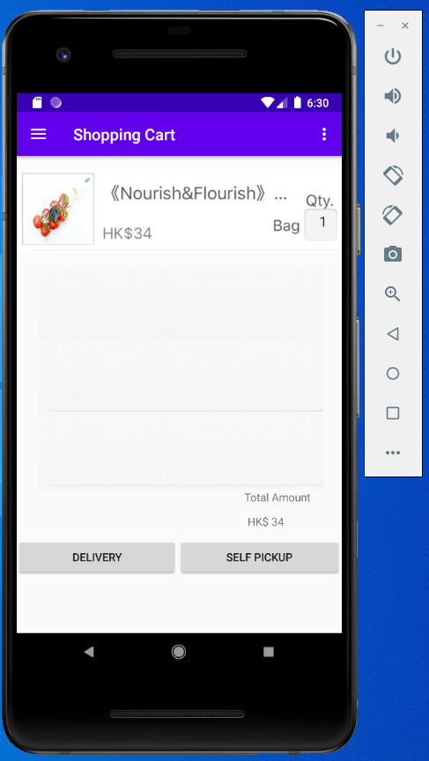

When users want to view their shopping cart, they can click the Shopping Cart option on the navigation bar and the Shopping Cart page will display. It will display many the items what the user added to shopping cart before. User can click the Edit text to change the quantity of the item. The Total Amount will be calculated automatically. Then, user can select “Delivery” or “Self Pickup” by click button with corresponding text to make order.

16.3.10 Make an order



**Step2**

**Step1**

Step 1: Add items to shopping cart by click the button with shopping cart icon.

Step 2: Click DELIVERY or SELF PICKUP button.

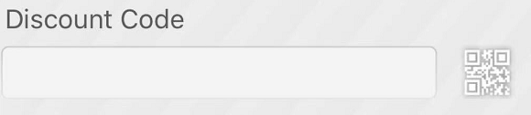

**Step7**

**Step6**

**Step5**

**Step4**

Step 3: Input your Shipping Address with details.

Step 4: Input Receiver and Phone number.

Step 5: Input discount Code If you have any available discount Code.

Step 6: Click the button (CONFIRM).



If you choose SELF PICKUP, users can scan the QR Code provided by shop to pay.



Payment Successful.

16.3.11 History Record



User can search the order record.

Step1: Input the Item name (tomato)

Step2: You see the history record under the Search Bar

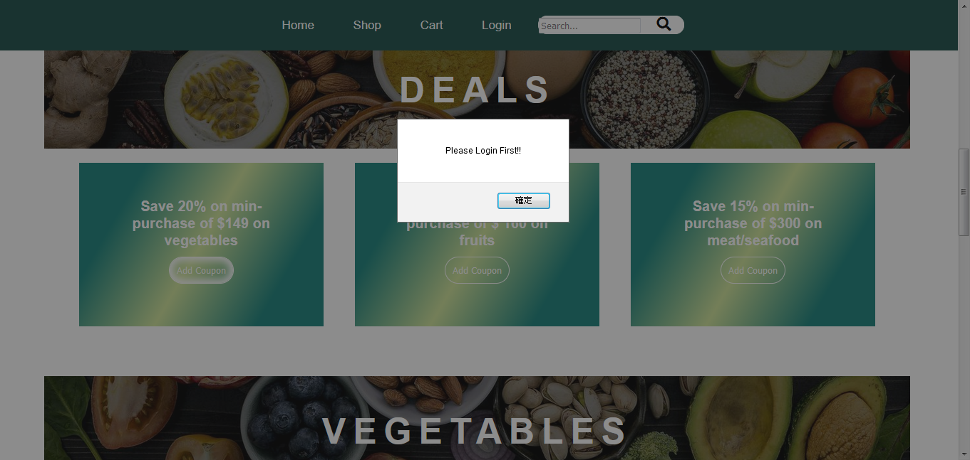

17 References

1. COVID-19 has changed online shopping forever, survey shows United Nations Conference on Trade and Development. Retrieved from <https://unctad.org/news/covid-19-has-changed-online-shopping-forever-survey-shows>
2. Selling on Online Marketplaces: Best Platforms for Selling Your Products. Cindy Puryear. Retrieved from

<https://www.bigcommerce.com/blog/online-marketplaces/#expanding-to-global-marketplace-audiences>

1. Keys to Hong Kong's development as a smart city – KPMG. Retrieved from <https://home.kpmg/cn/en/home/news-media/press-releases/2020/04/technology-infrastructure-access-to-qualified-talent-and-r-and-d-spend-are-key-to-hong-kong-s-development-as-a-smart-city.html>
2. Designing smart markets. International Journal of Modern Trends in

Engineering & Research. Retrieved from

<https://www.researchgate.net/publication/241861009_Designing_smart_markets>